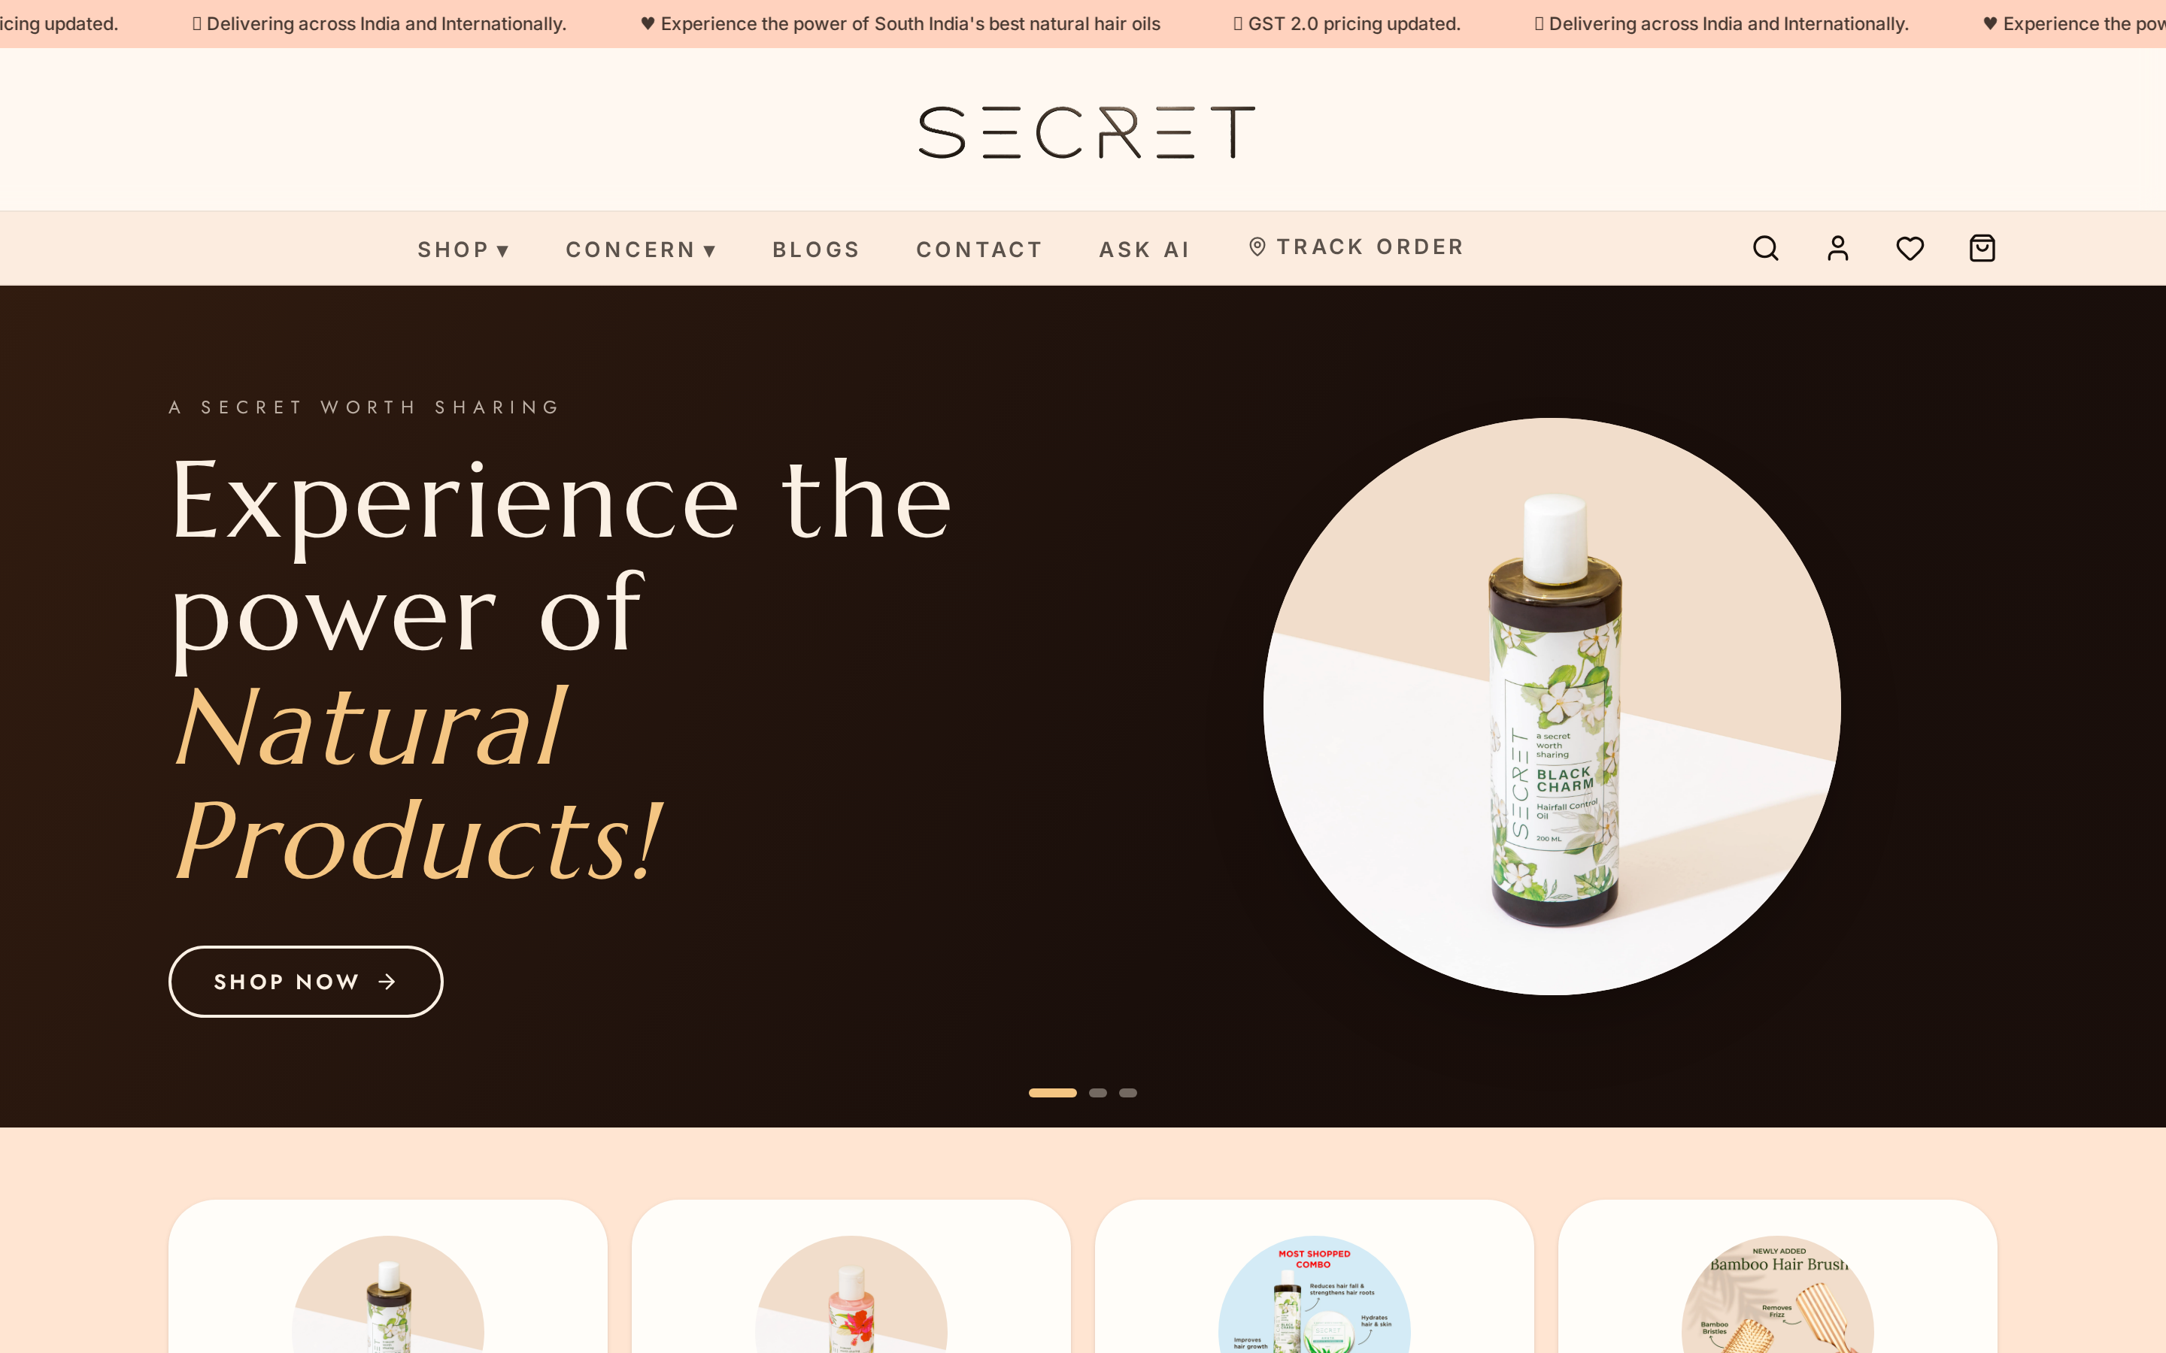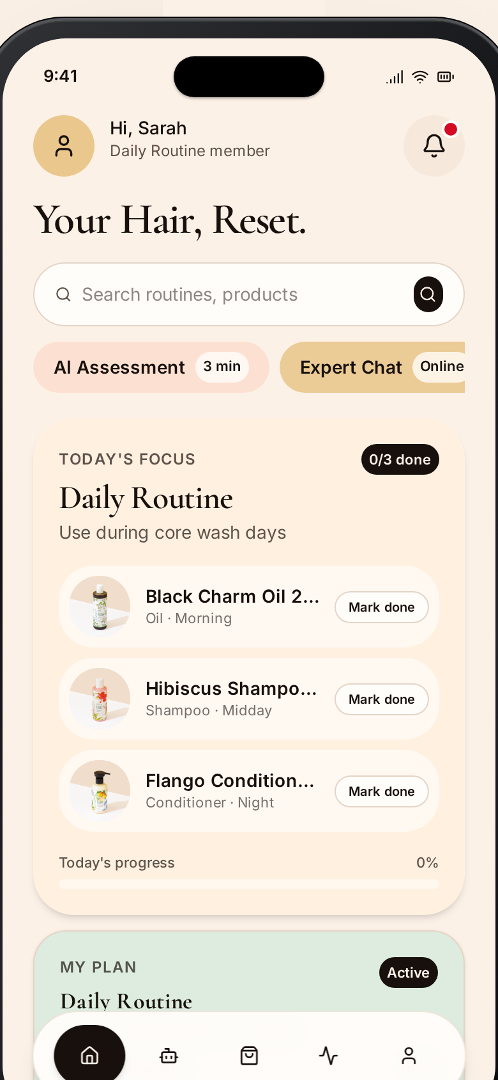
Secret Hair Journey
Proposal — Intelligent Hair Care & Tracking Platform
Interactive Prototype is hosted at https://secrethaircare.online


This proposal strategically leverages prototype screens and representative data to enhance the visualization and clearly articulate the functionality and value of each module.

Introduction
Dear Team,
Thank you for the opportunity to present this proposal. We appreciate the trust extended to us and recognize the strategic importance of this initiative in revolutionizing personal hair care through data, tracking, and personalized routines.
Our agency specializes in designing and delivering AI-driven consumer platforms for complex, highly personalized journeys — particularly where health, wellness, and e-commerce intersect. Through our analysis of the The Secret Hair Care prototype, it is clear that the modern consumer struggles with generic hair care advice, fragmented routines, and a lack of measurable progress tracking. Addressing this requires a unified, intelligent system connecting assessment, personalized routines, progress tracking, and product discovery into a single ecosystem.
This proposal is guided by four principles:
- Hyper-Personalization — routines built around real individual hair profiles, not generic demographics.
- Visual Validation — seamless photo tracking and side-by-side comparisons to prove product efficacy.
- Frictionless UX — an intuitive, mobile-first design that builds daily habits effortlessly.
- Embedded Intelligence — AI insights integrated into product recommendations and routine adjustments.
Warm regards,
The Development Team

1. Executive Summary
We propose to design and implement The Secret Hair Care, a cloud-based, AI-enhanced ecosystem that transforms how users understand, manage, and track their hair health. The platform is divided into four dedicated interfaces: Consumer Mobile App, Consumer Web App, Expert's Panel, and Admin Panel.
The unified user flow:
Assess Profile → Generate Routine → Track Progress → Analyze Results → Recommend Adjustments

Expected Outcomes
- +40% increase in routine adherence via smart scheduling and push reminders.
- Highly engaged user base — the visual progress tracker creates a powerful weekly habit loop.
- Data-driven product sales through algorithm-matched recommendations based on porosity, density and scalp health.

2. Understanding of Business & Current Challenges
The platform operates at the intersection of three verticals:
- Personal Grooming & Wellness
- Habit Tracking & Analytics
- E-commerce / Product Discovery

Key Challenges Identified
- Fragmented routine management — users track wash days and treatments in their head or generic note apps, leading to missed treatments and stalled progress.
- Lack of visual proof — without a dedicated visual timeline, users lose motivation between Day 1 and Day 60.
- Product confusion — users don't know their porosity or scalp type and end up with incompatible products that cause buildup or breakage.
- No feedback loop — generic platforms can't adapt routines as a user's hair transitions from damaged to healthy.

3. Solution Overview — The Secret Hair Care
The Secret Hair Care is designed as an intelligent ecosystem connecting assessment, scheduling, professional consultation, and product discovery into a single habit-building engine.

Core Capabilities
- Smart Profile Assessment — comprehensive onboarding capturing hair type (1A to 4C), porosity, scalp condition, goals and environmental factors.
- Dynamic Routine Builder — automatically translates the profile into a weekly schedule with wash days, deep conditioning, oiling and trims.
- Visual Journey Tracker — secure private photo diary with grid overlays to visualize length retention and thickness improvements.
- Expert Guidance — dedicated channel for trichologists and hair experts to review progress, tweak AI routines and prescribe products.

4. End-to-End Workflow
- Onboarding & Assessment — quiz on current hair state, past chemical treatments and goals.
- Routine Generation — algorithm produces a personalized 30-day calendar.
- Daily Execution — gentle push reminders for today's tasks (e.g. "Scalp Massage — 5 mins" or "Clarifying Wash Day").
- Logging & Tracking — user logs completion and uploads bi-weekly progress photos to The Journey.
- Expert / Algorithm Adjustment — system or assigned expert reviews data and adjusts the routine dynamically.
- Product Discovery — user shops for or discovers new products exactly when their routine calls for them.

5. Solution Architecture
- Frontend — responsive Progressive Web App built with React / TanStack Start and Tailwind CSS, native-like across all devices.
- Backend — secure, scalable cloud infrastructure (Node + serverless) for authentication, scheduling logic and multi-tenant data.
- Database — PostgreSQL for structured user data, routines and product catalogs with secure cloud storage for the private photo gallery.
- Intelligence Layer — custom algorithms mapping hair types and concerns to structured routines and ingredient lists.

6. Product Experience & Application Interfaces
To deliver a comprehensive ecosystem, the platform is divided into four distinct portals, each tailored to its specific user persona. The screenshots that follow are taken directly from the live interactive prototype.

6.1 Consumer Mobile App (PWA)
The daily companion for end-users, optimized for on-the-go tracking and bathroom usage.
- Welcome & OTP Sign-in — phone-first, password-less authentication.
- Today's Dashboard — greeting, hair-health streak and Today's Focus checklist.
- AI Hair Assessment — adaptive quiz on porosity, density, scalp condition, chemical history and goals; produces the user's Hair ID.
- Shop & Product Cabinet — Hair-ID-filtered catalog with concern, type and category filters, wishlist, cart and checkout (UPI · Card · Netbanking).
- The Journey (Tracking) — photo diary with grid overlays, Compare slider between any two dates and consistency metrics.
- Profile & Subscriptions — saved address, order history, active subscription plan, expert chat and notifications.
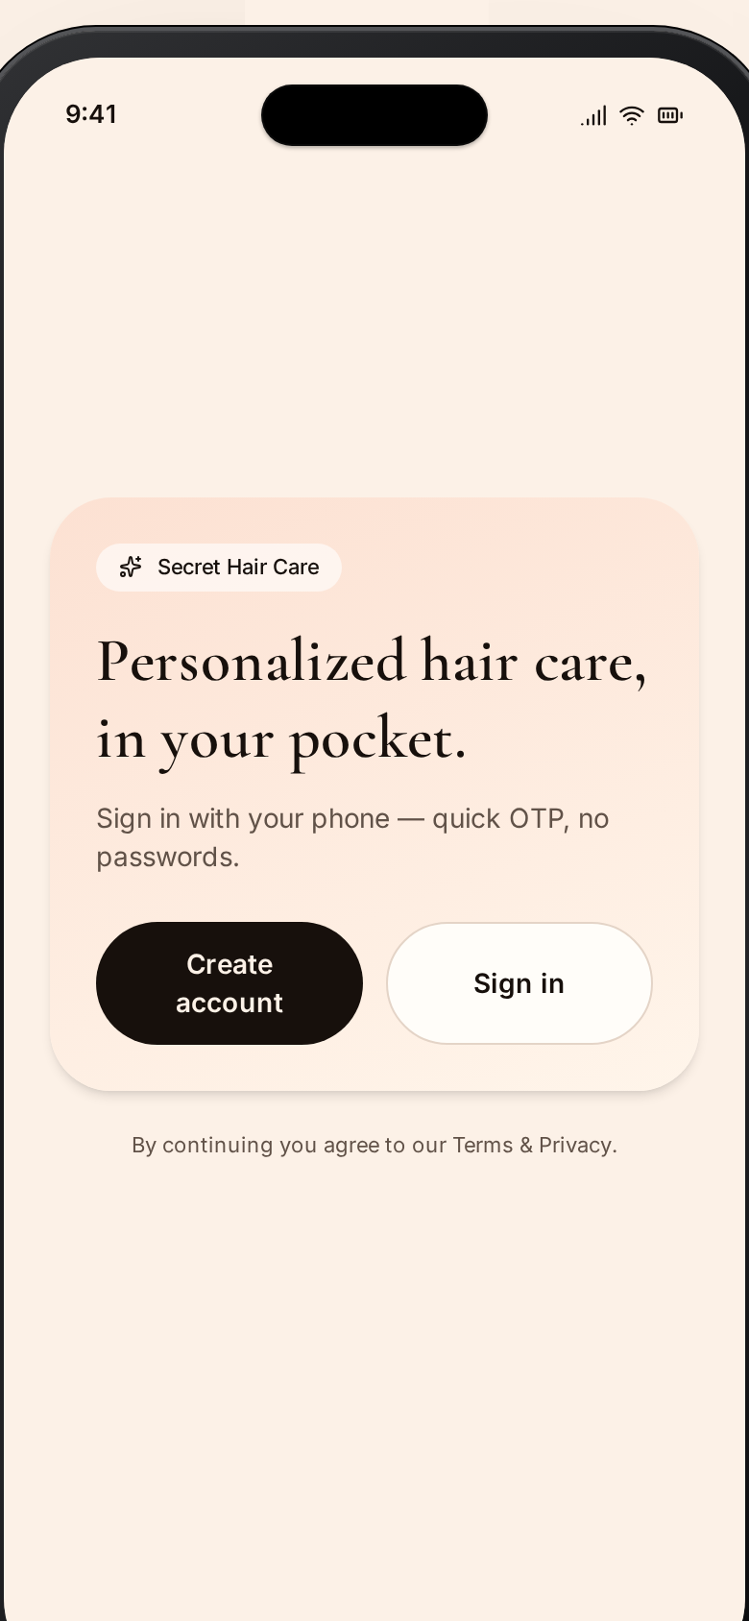
Fig. 1. Welcome & Sign-in — Frictionless OTP-first onboarding.
Fig. 2. Today's Dashboard — Daily greeting, hair-health streak, Today's Focus checklist.
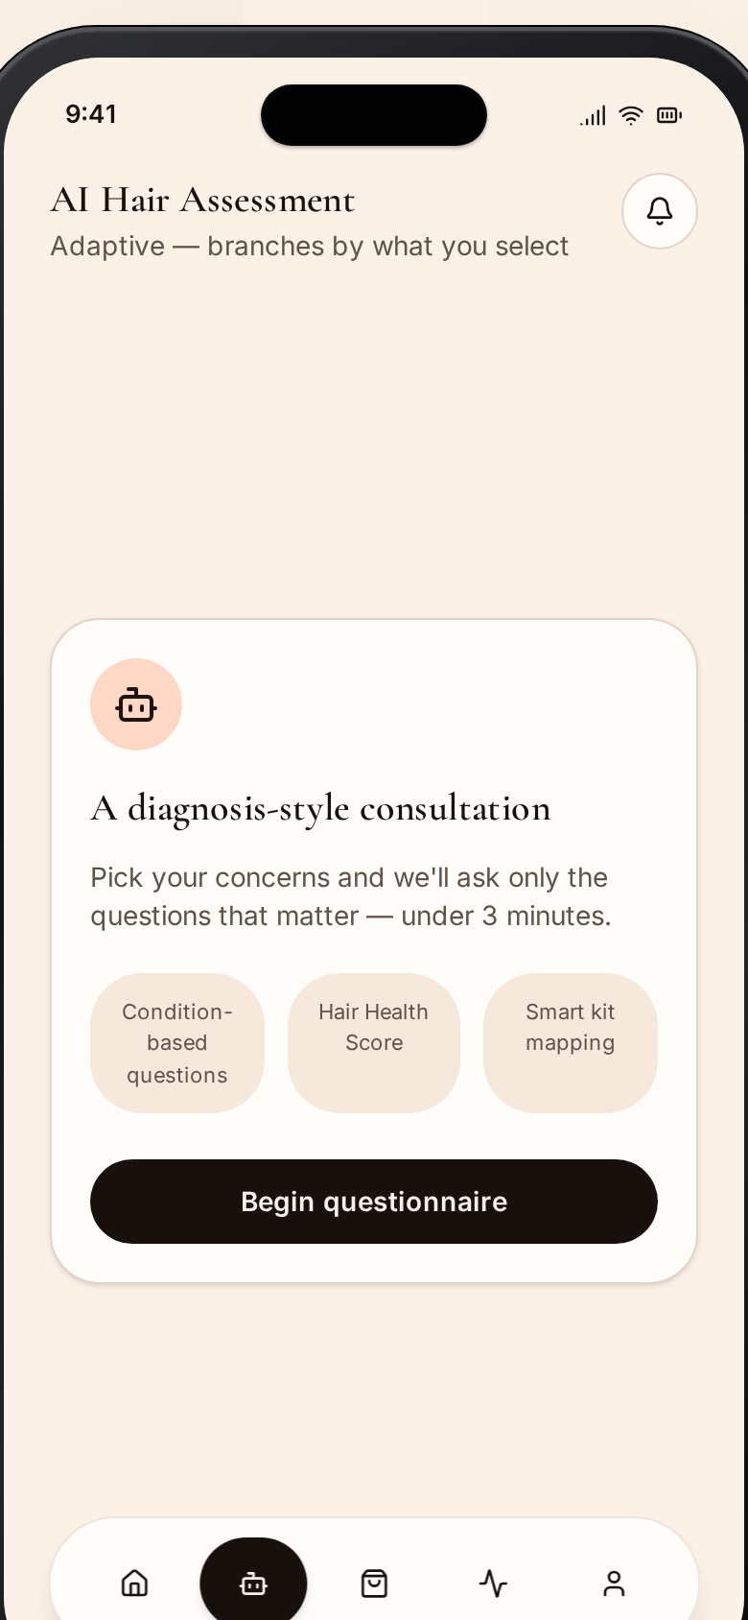
Fig. 3. AI Hair Assessment — Adaptive quiz that produces the user's Hair ID.
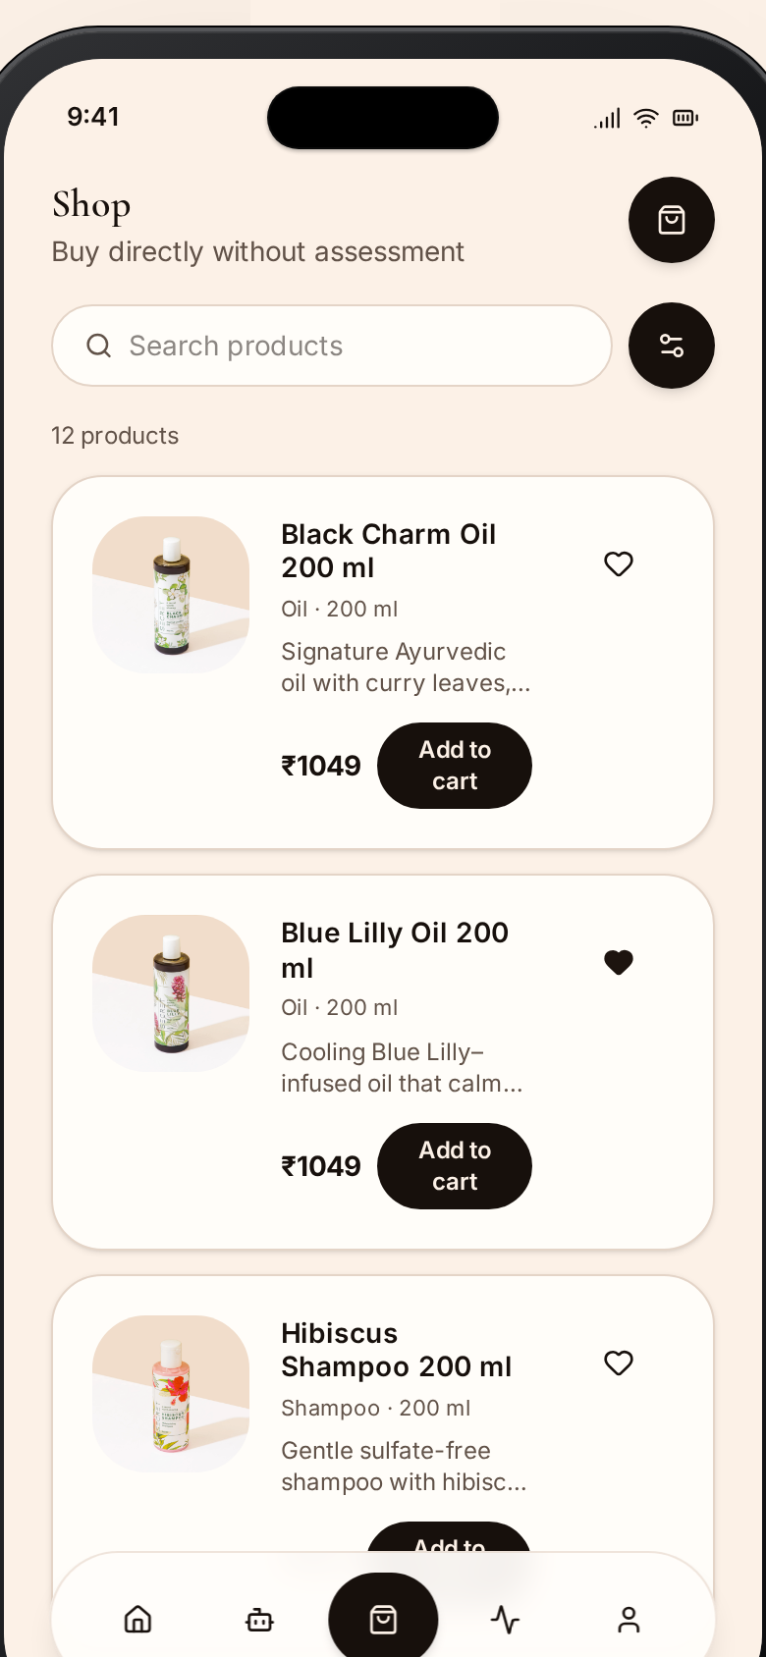
Fig. 4. Shop & Product Cabinet — Catalog filtered by Hair ID with wishlist & cart.
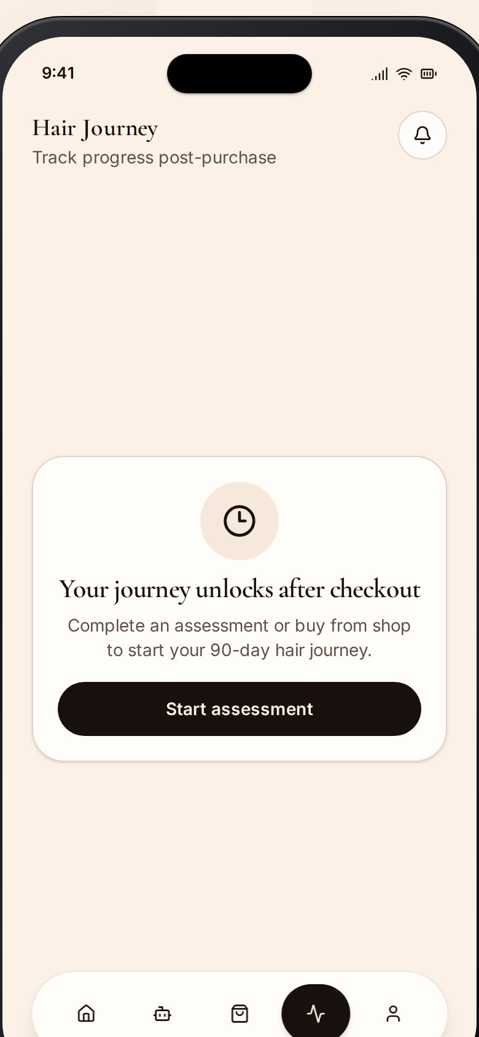
Fig. 5. The Journey — Photo diary with Compare slider and consistency metrics.
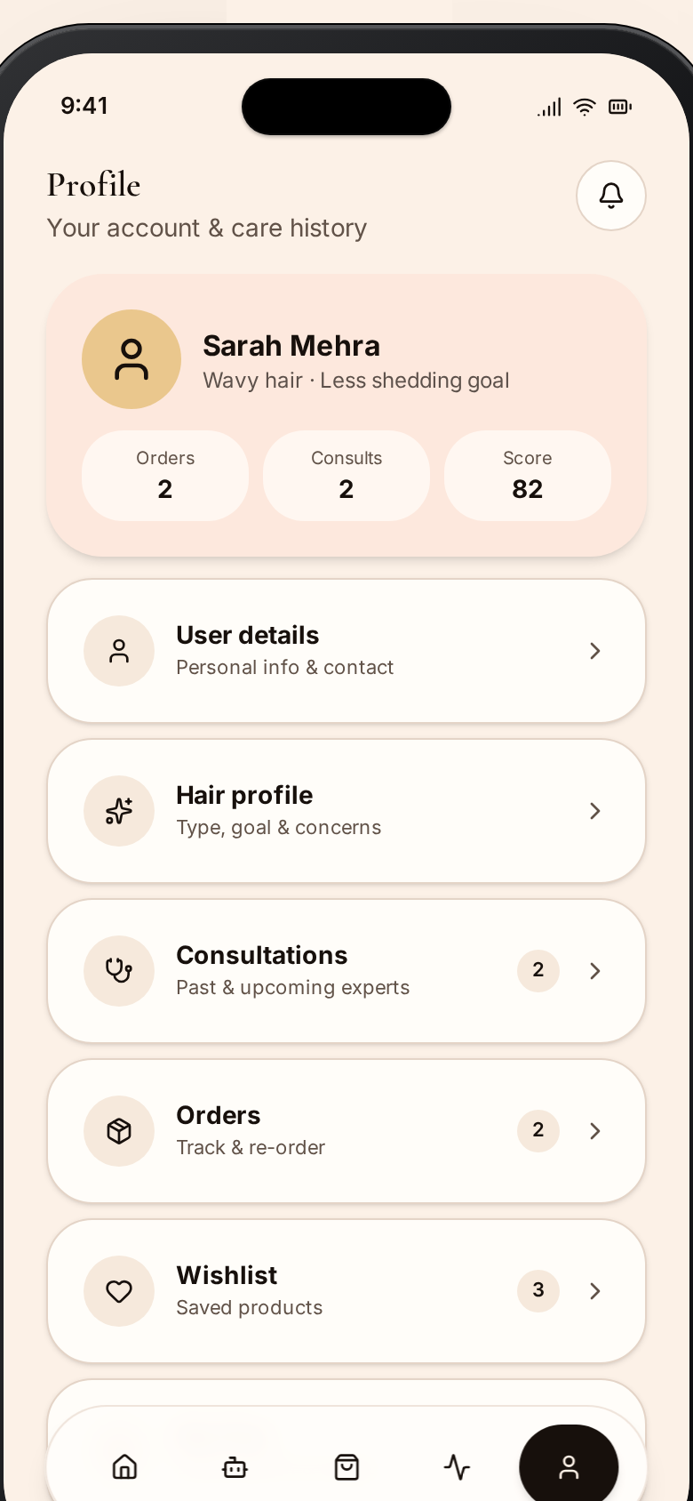
Fig. 6. Profile & Subscriptions — Account, address, orders and subscription plan.

6.2 Consumer Web App
The desktop hub for deep-dive analytics, shopping, and long-term planning.
- Storefront & Brand — premium responsive home with hero, brand story and gateways into Shop, Ask-AI and the Journal.
- Shop, Categories & Concern Hubs — global catalog plus curated category and concern landing pages bundling routines, products and content.
- Product Detail — ingredient transparency, reviews, recommended-with picks and add-to-cart with one-tap subscription.
- Cart, Checkout & Order Tracking — single-page checkout with applied coupons and shipping; live order status and carrier ETA.
- Account & Hair ID — saved profile, addresses, order history, active subscription and the Hair ID card.
- Ask AI — conversational assistant that turns the quiz into an instant personalized routine.
- Journal & Reviews — internal SEO blog content plus verified reviews with photos and ratings breakdown.
- About & Contact — brand story and direct support channels.
Fig. 7. Home / Storefront — Premium responsive landing with brand story.
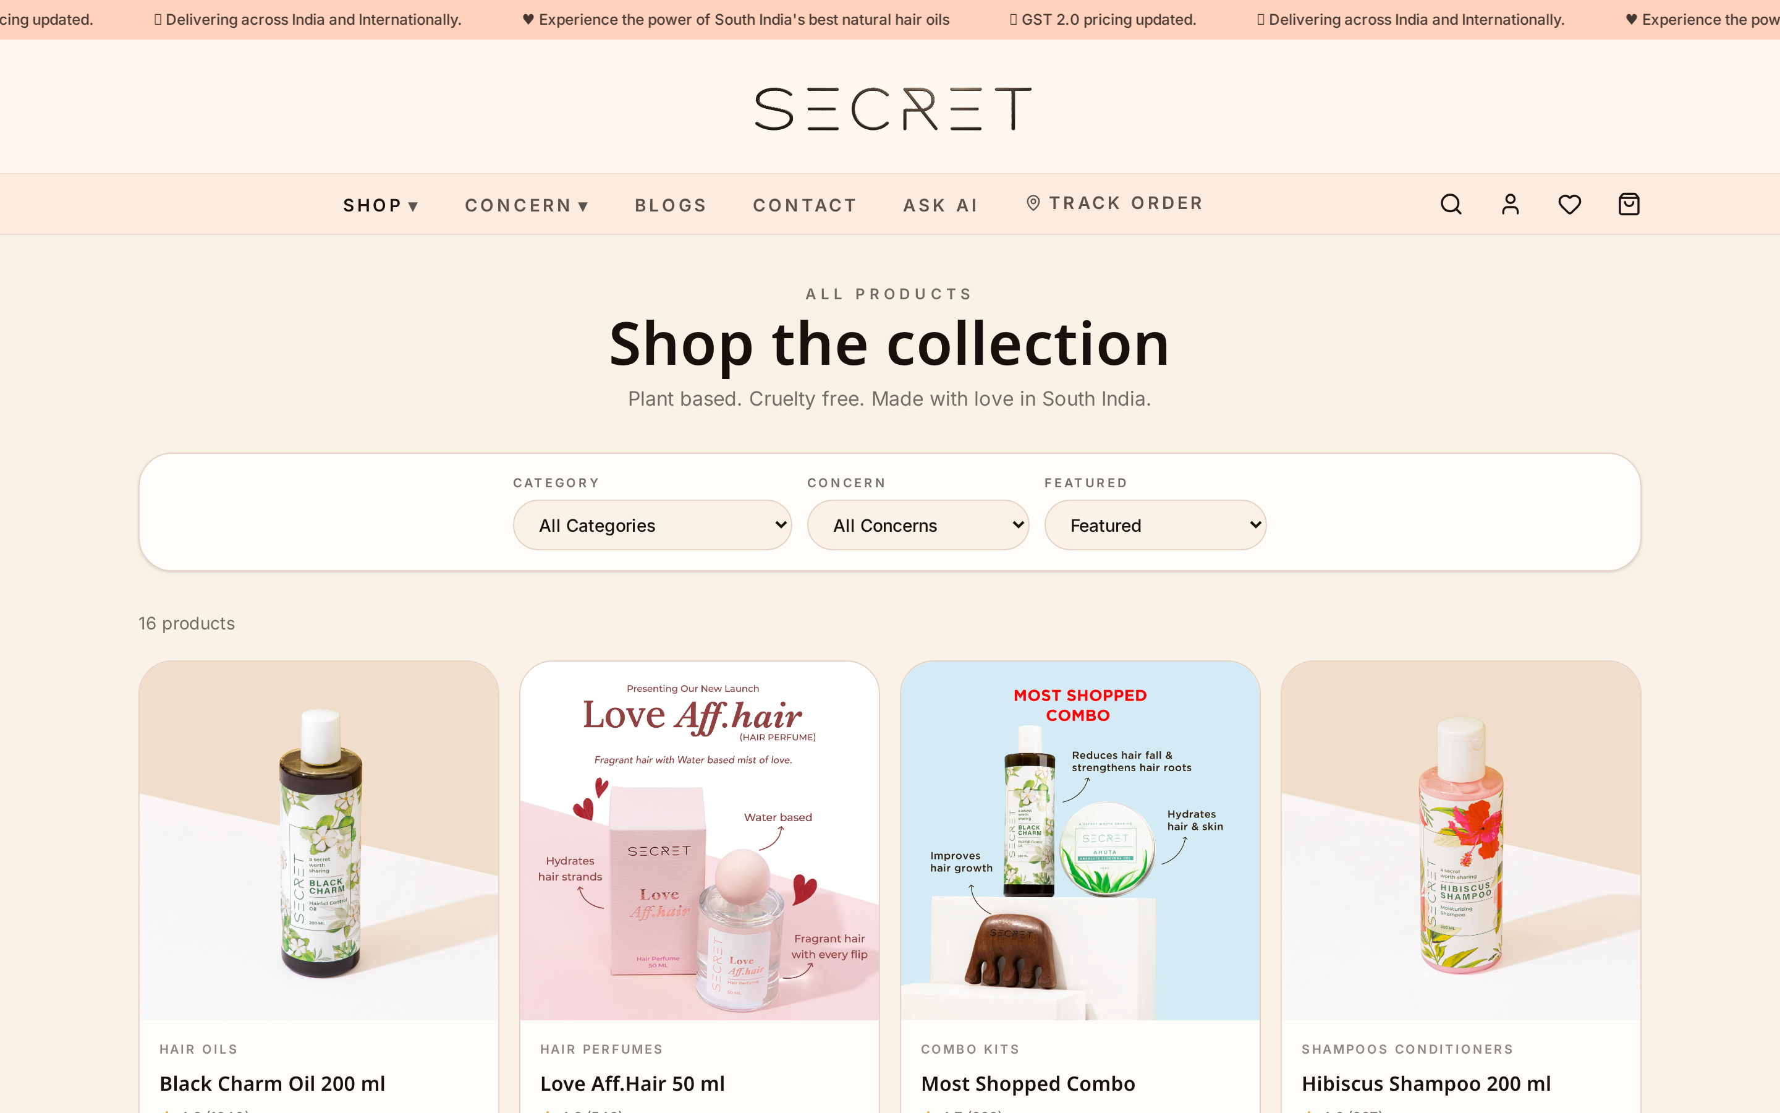
Fig. 8. Shop — Product Matchmaker filtered by Hair ID.
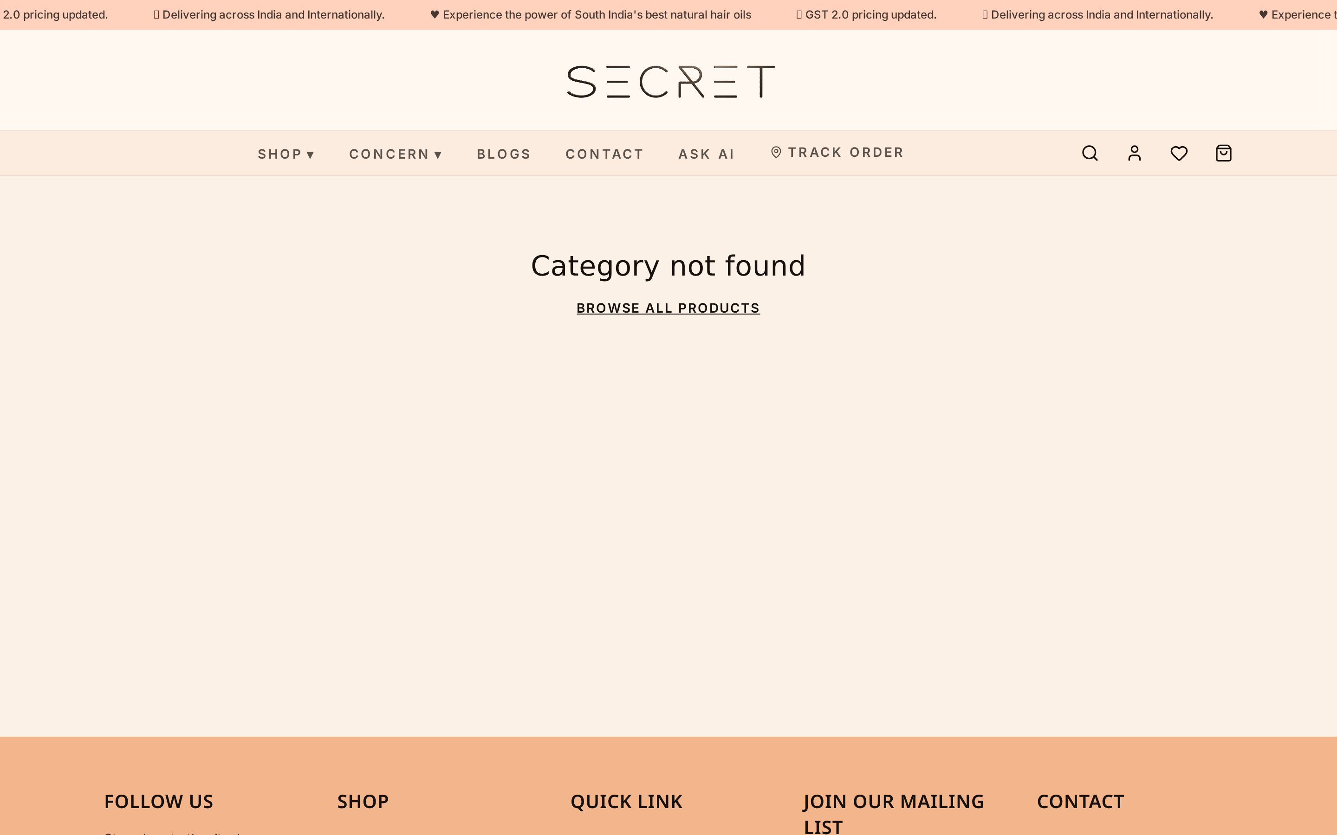
Fig. 9. Category Page — Curated browsing with filters.
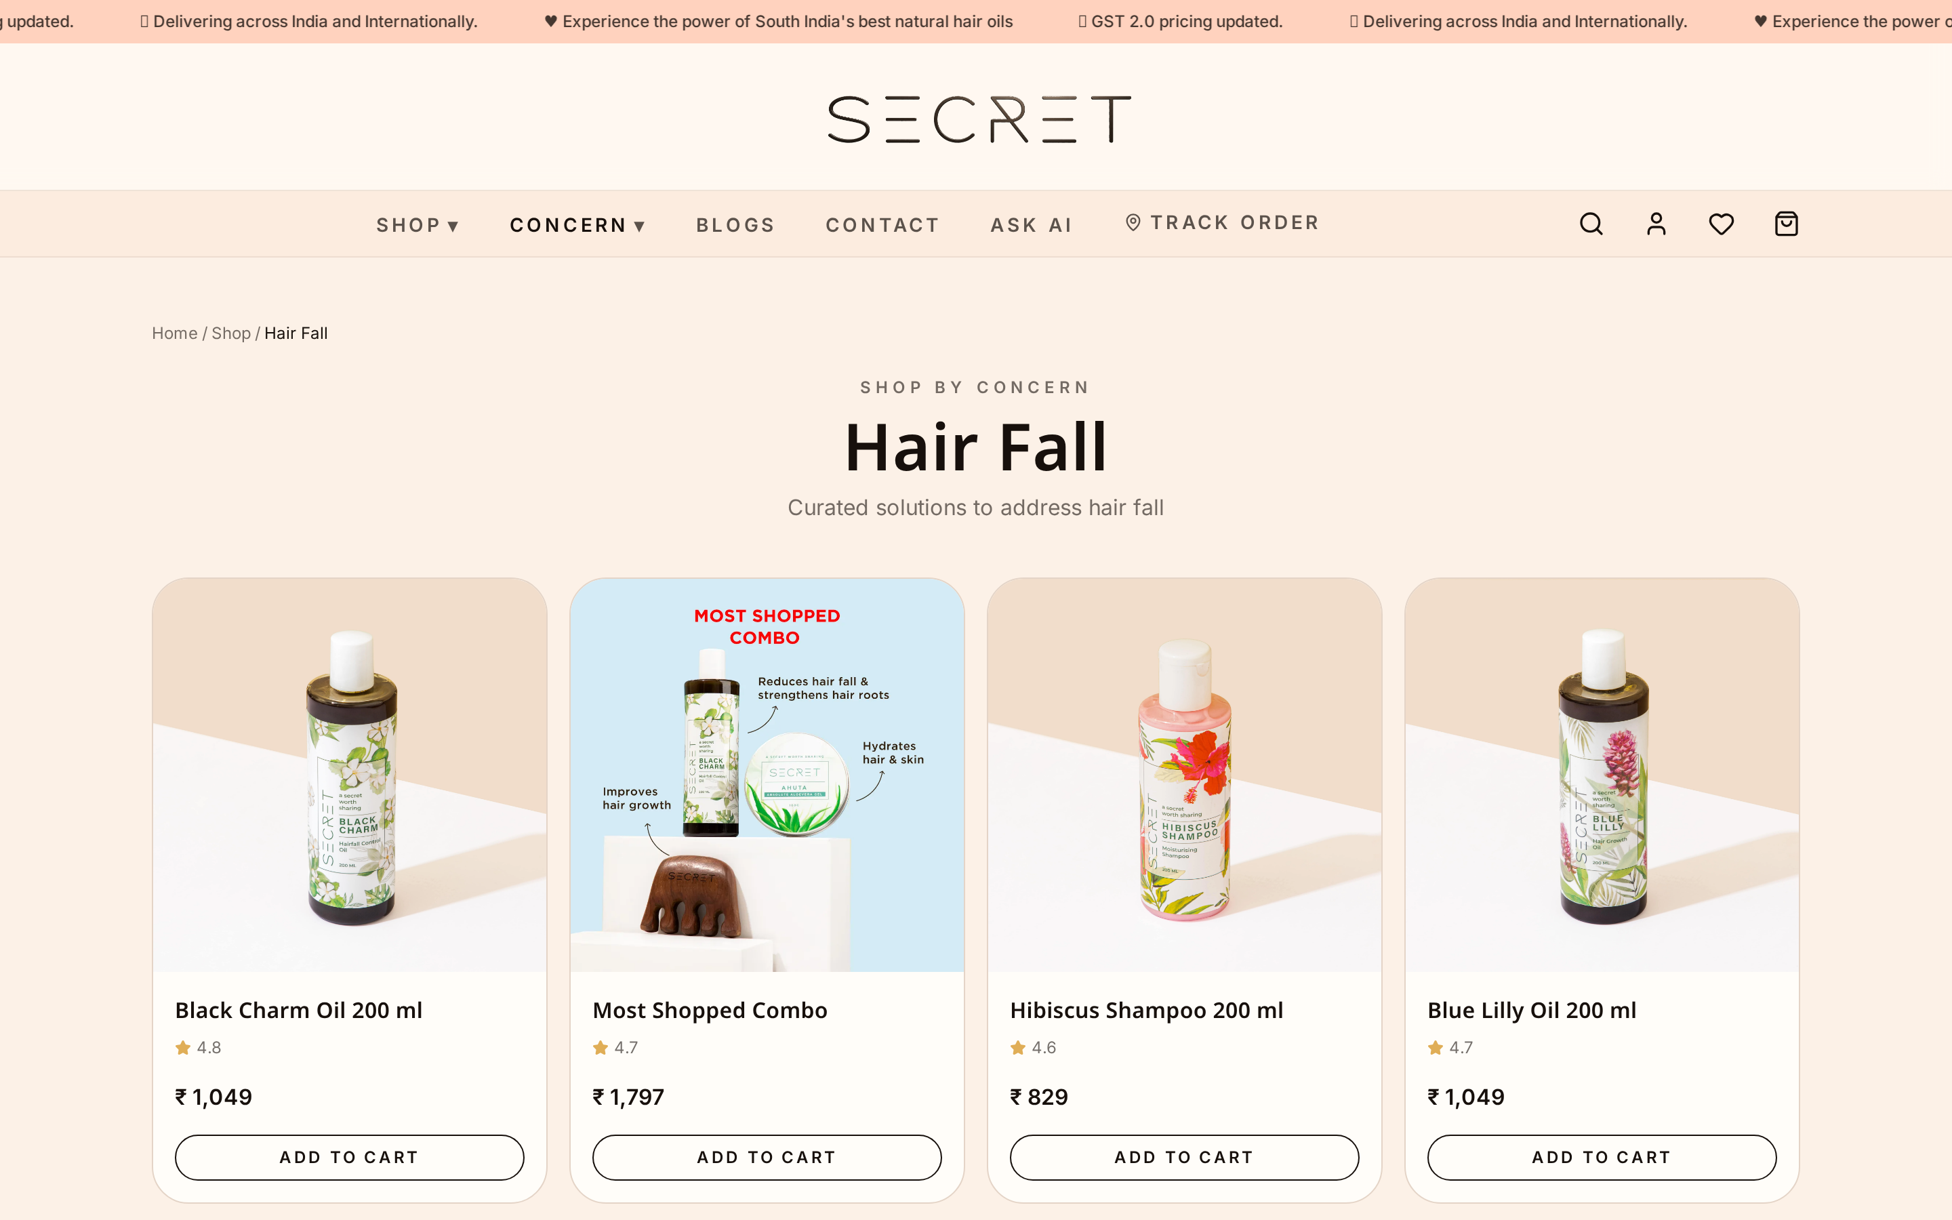
Fig. 10. Concern Hub — Concern-driven landing pages bundling routines & products.
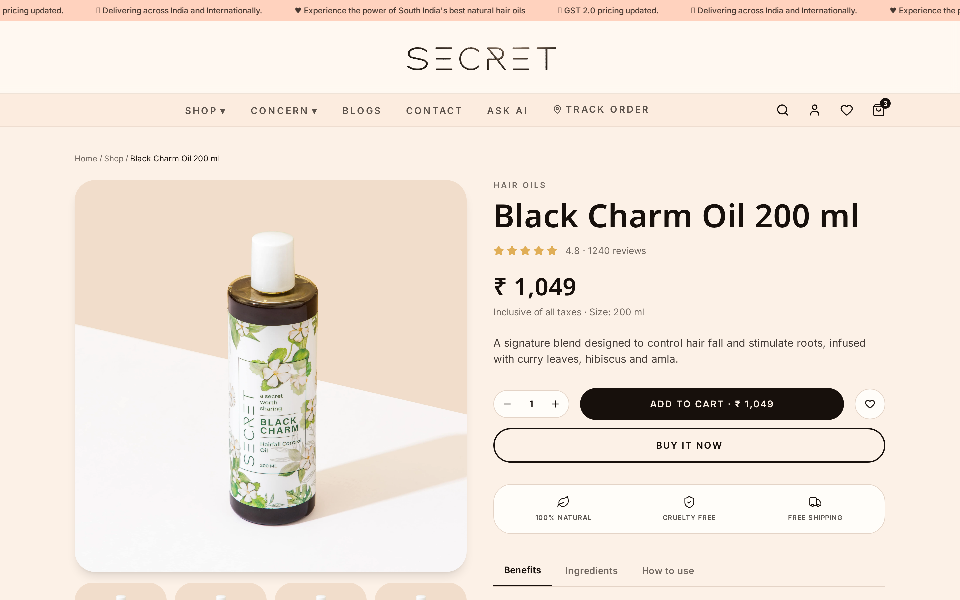
Fig. 11. Product Detail — Ingredient transparency, reviews, recommendations.
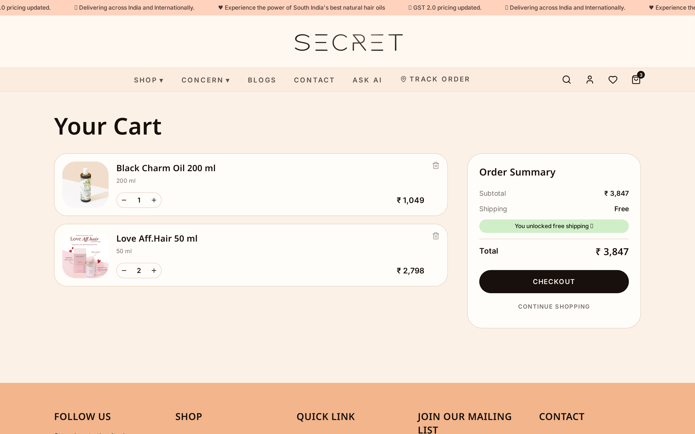
Fig. 12. Cart — Editable cart with coupons and free-delivery progress.
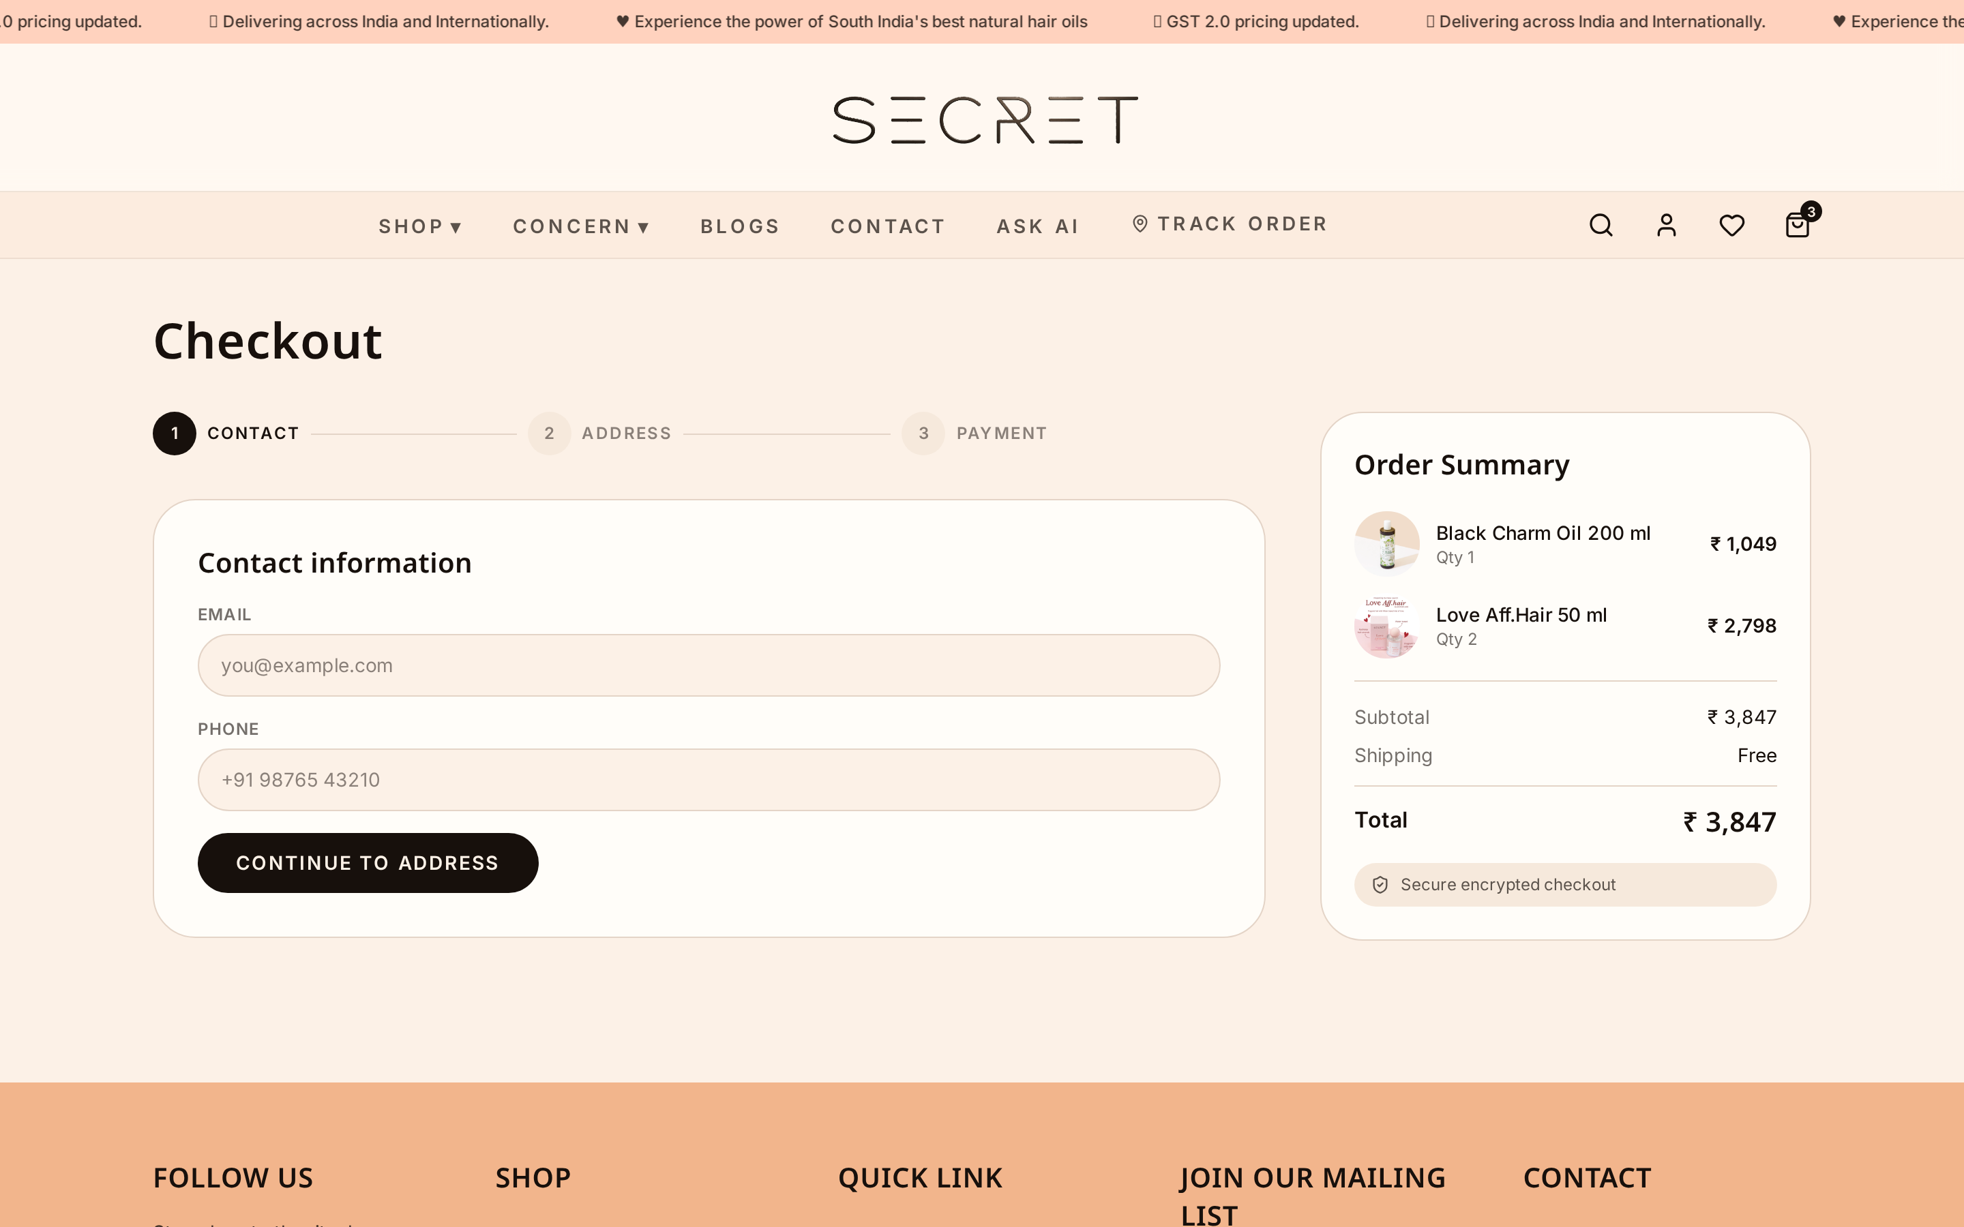
Fig. 13. Checkout — Single-page checkout with UPI / Card / Netbanking.
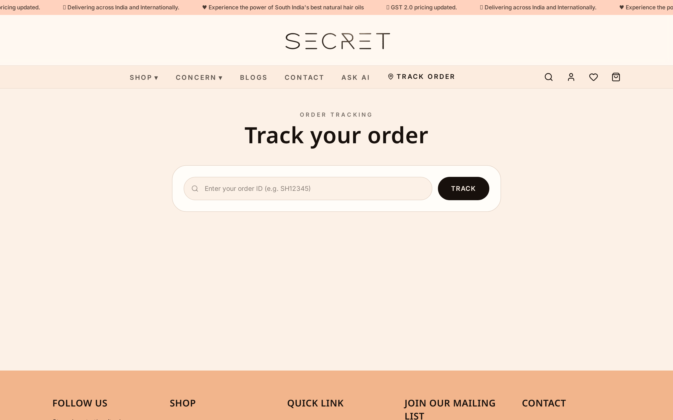
Fig. 14. Order Tracking — Real-time status, carrier tracking and ETA.
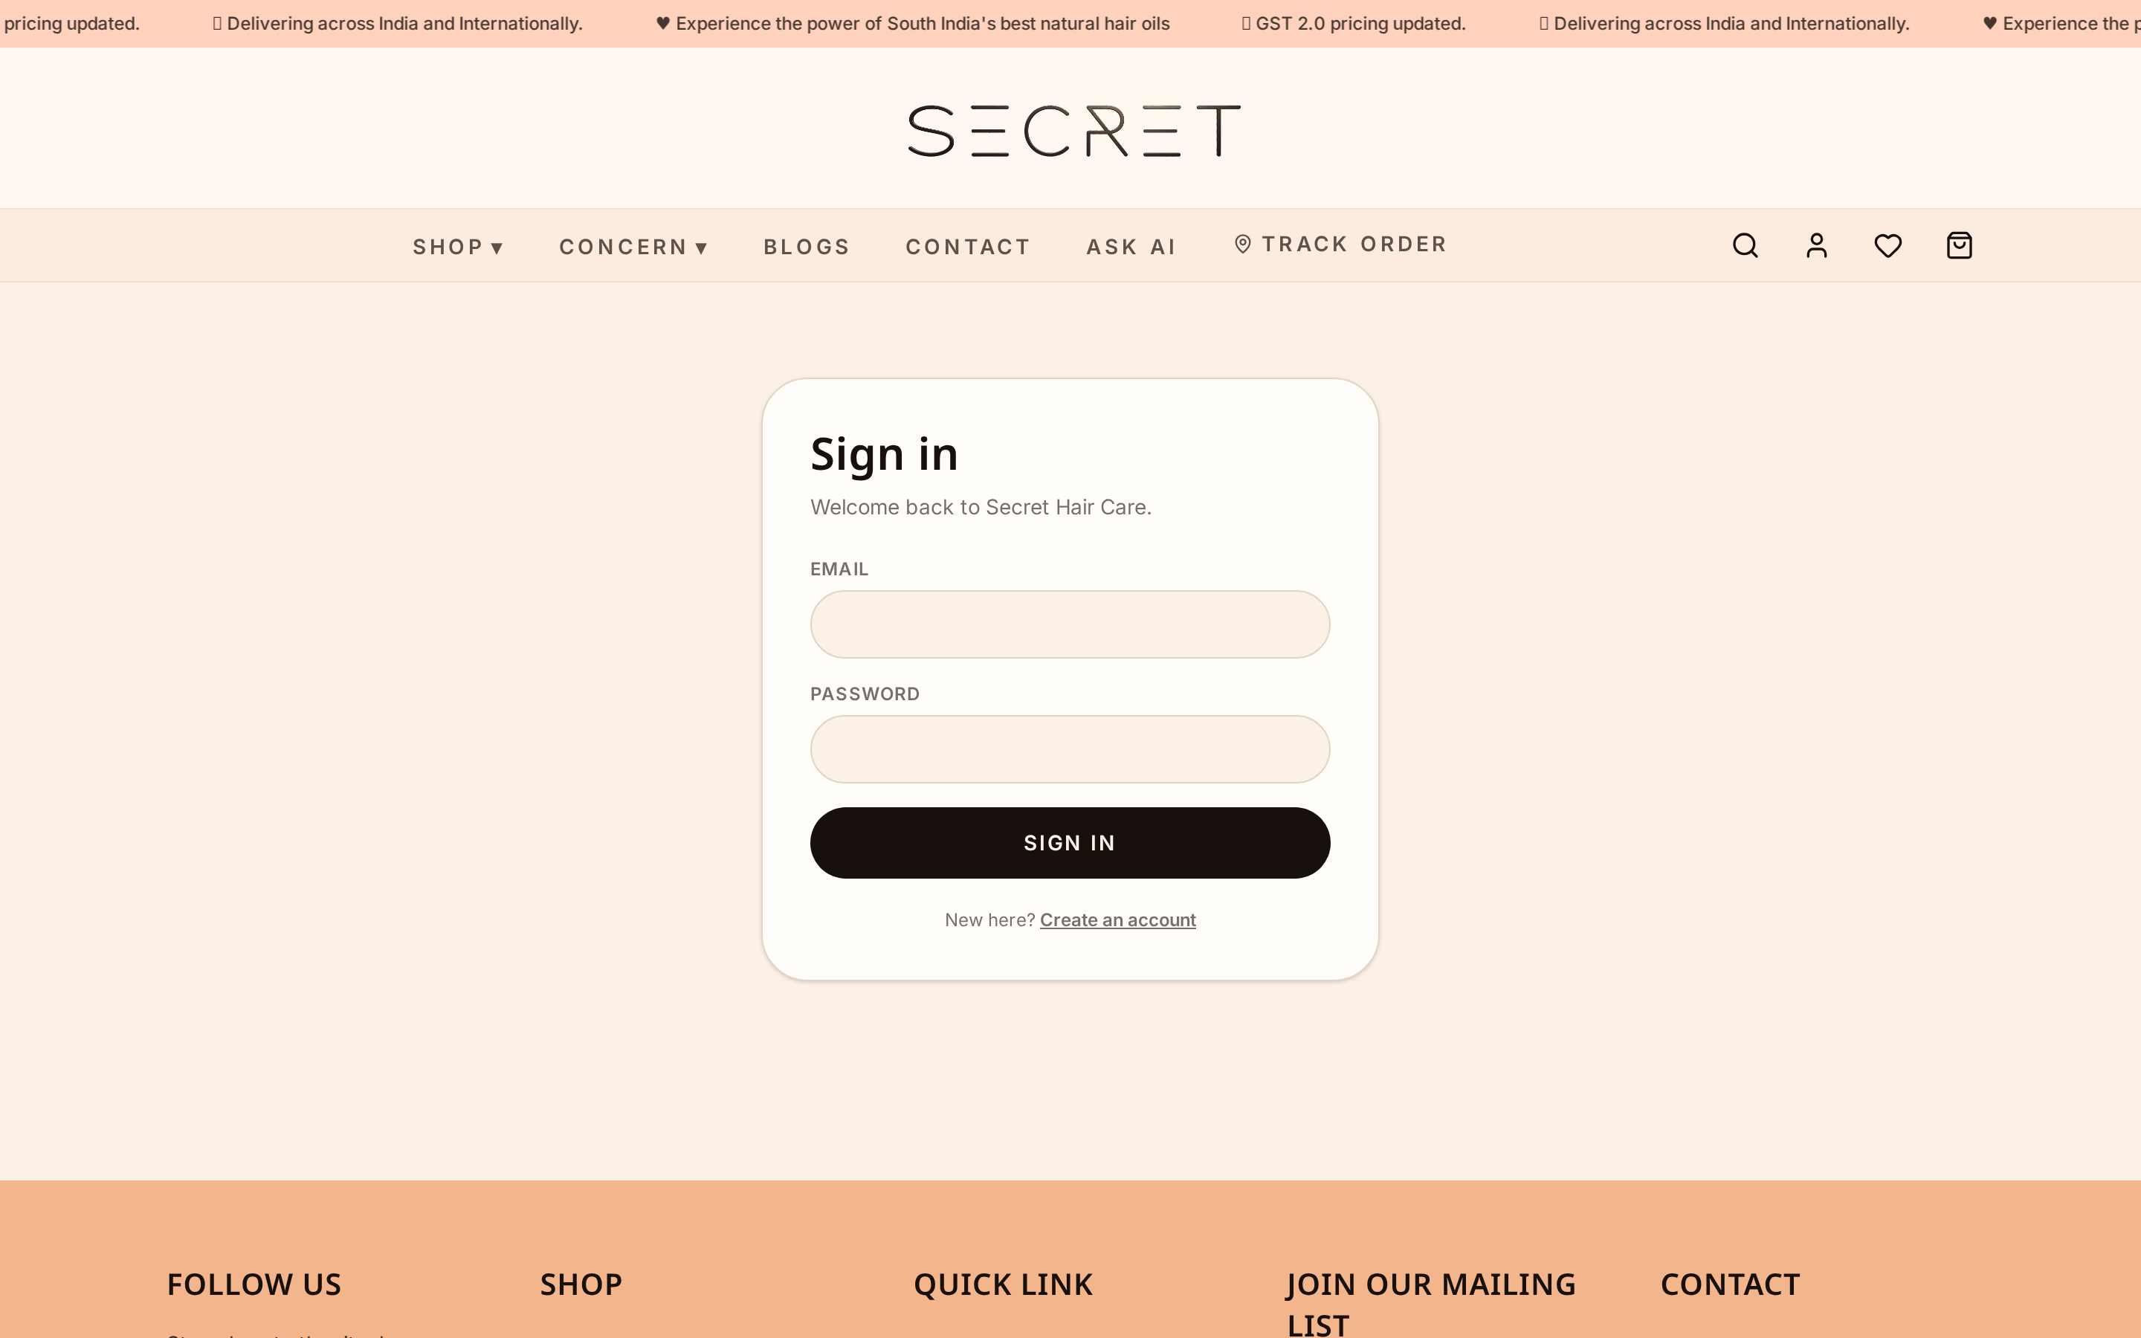
Fig. 15. Account / Hair ID — Profile, addresses, orders and subscription.
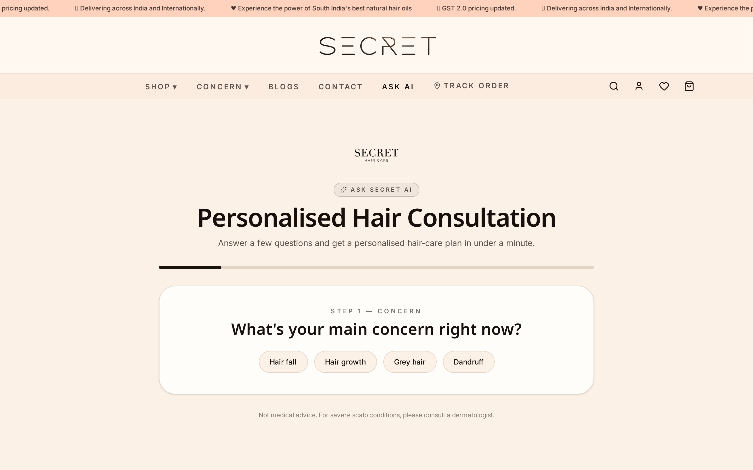
Fig. 16. Ask AI — Conversational assistant with personalized routine.
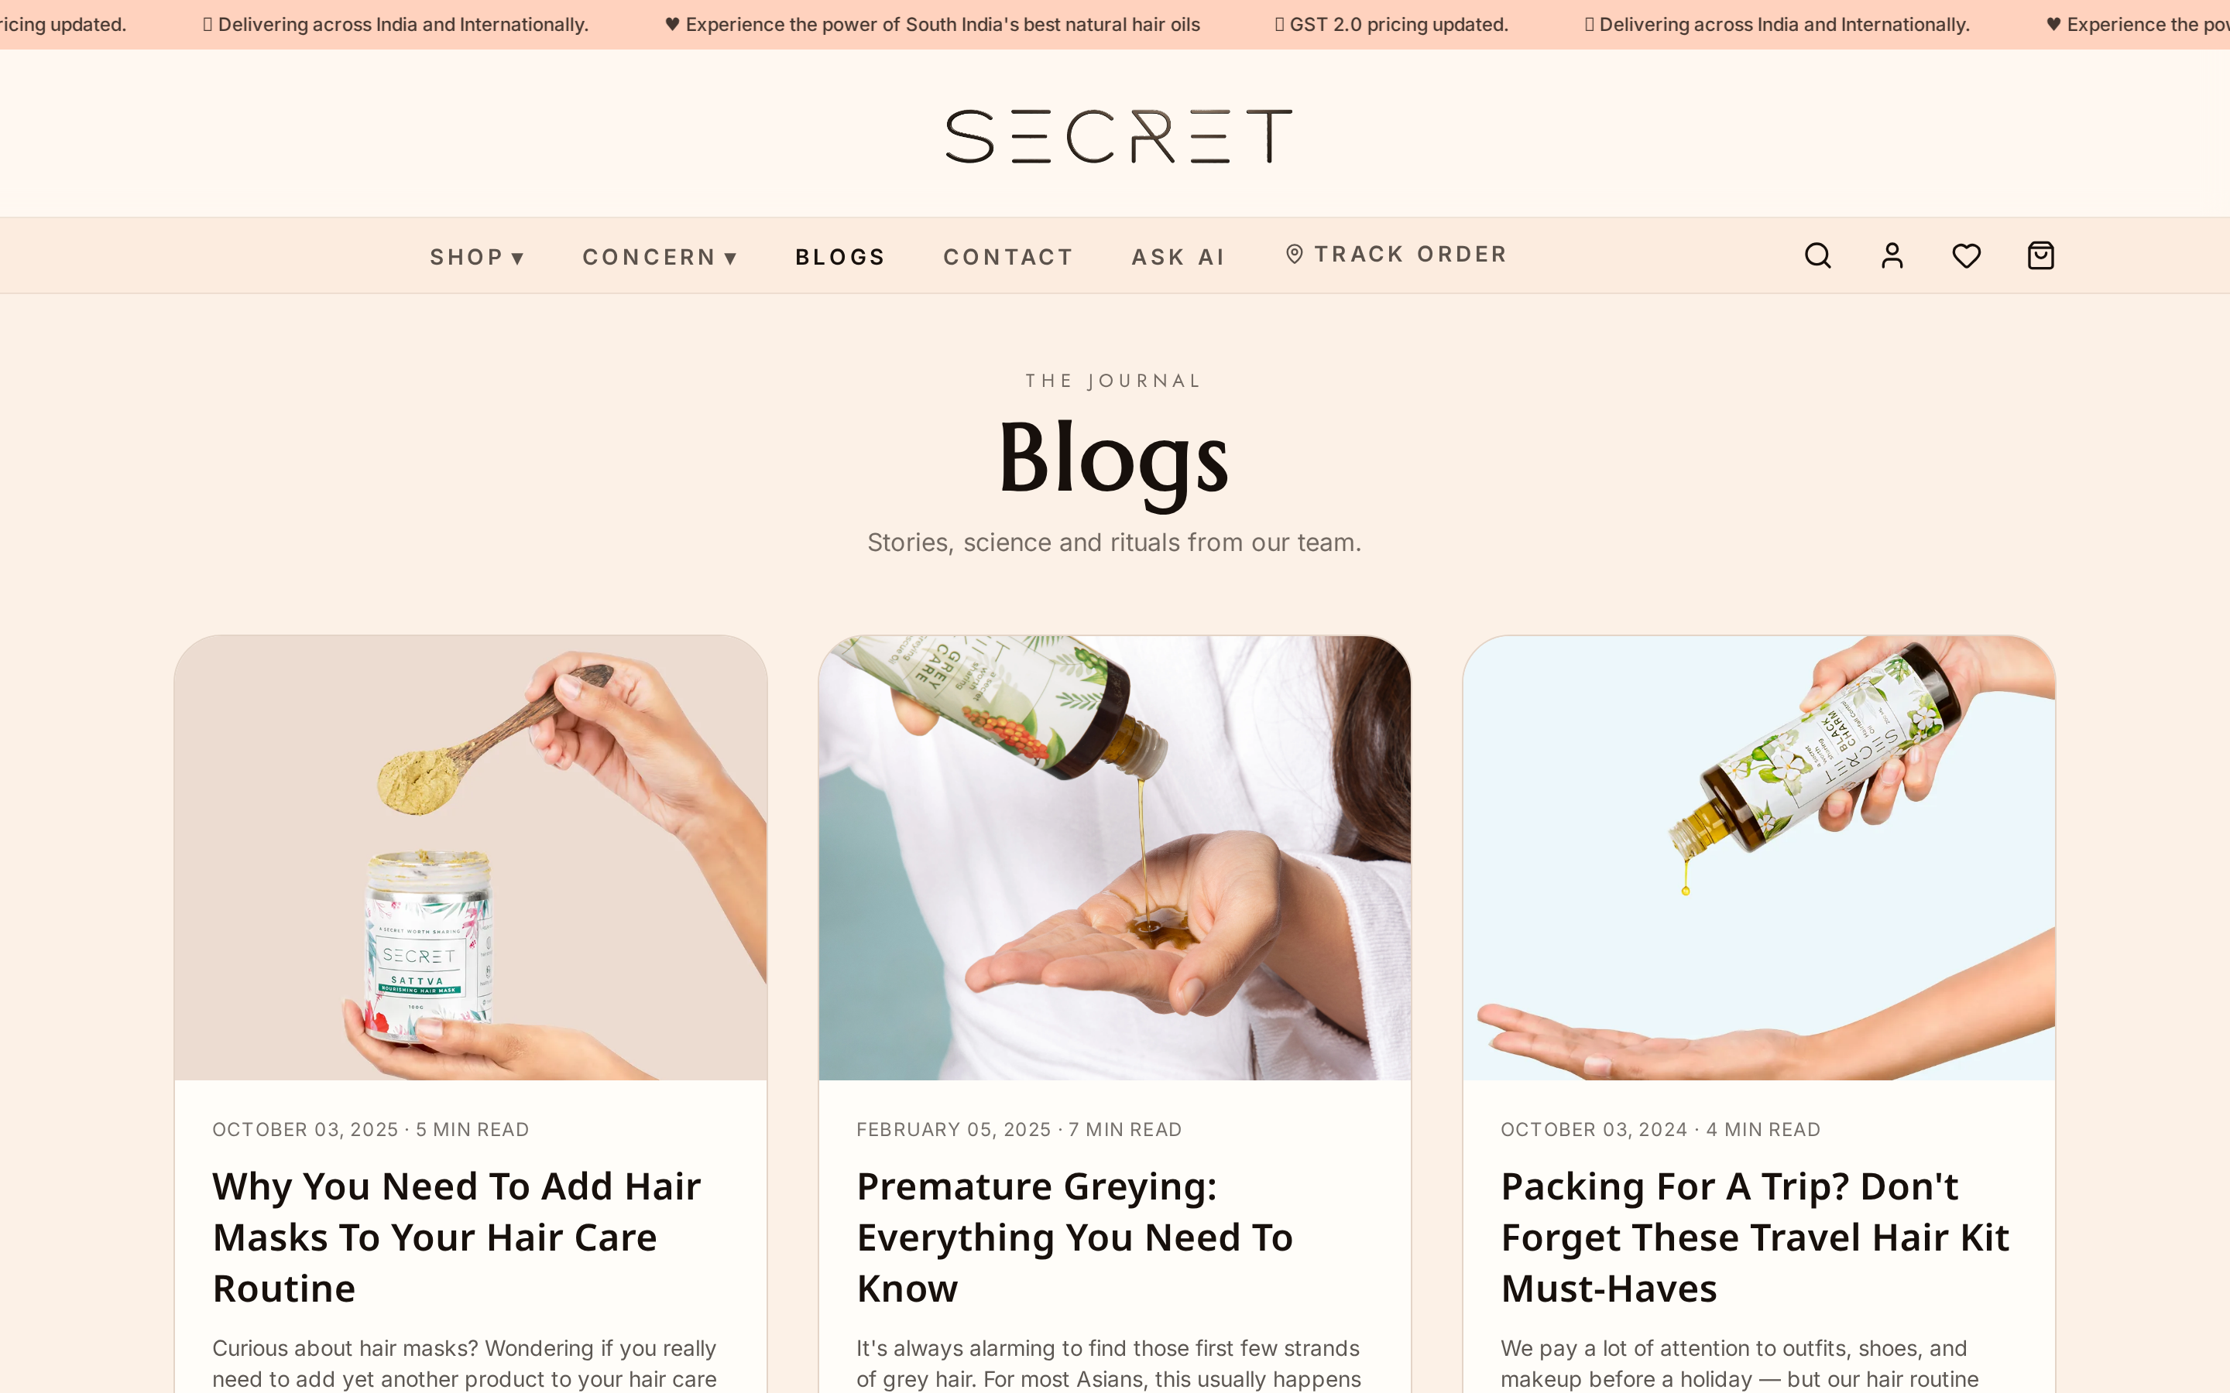
Fig. 17. Journal — Science-led blog content for SEO.
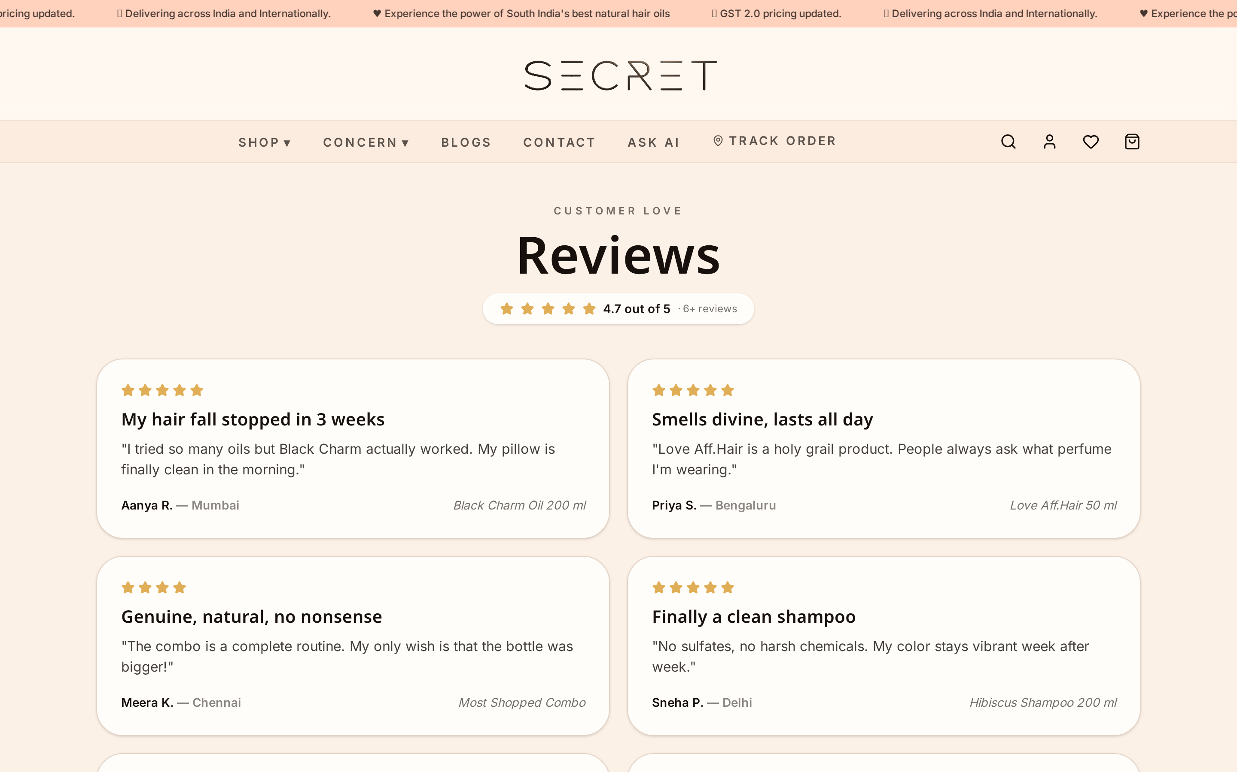
Fig. 18. Reviews — Verified reviews with photos and ratings breakdown.
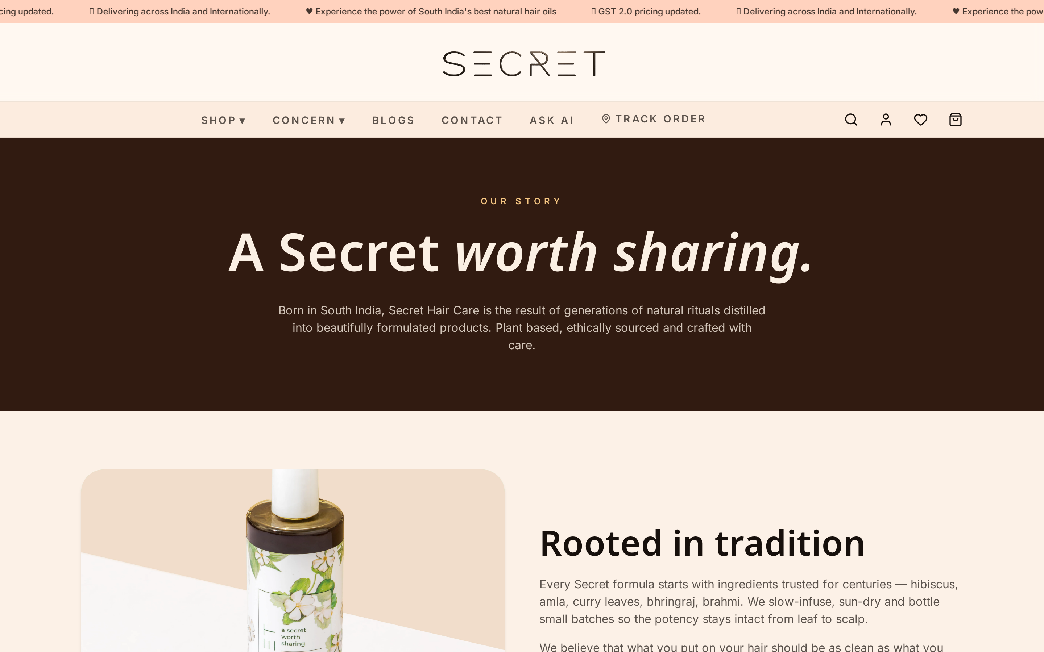
Fig. 19. About — Brand story, founder note and craftsmanship.
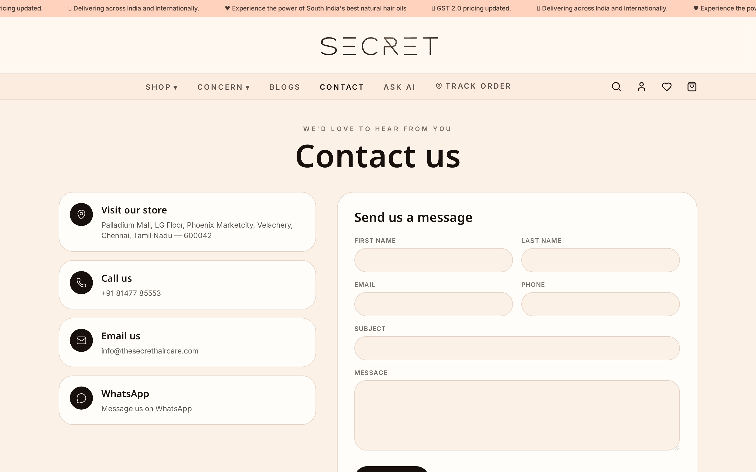
Fig. 20. Contact — Direct contact form and brand support channels.

6.3 Expert's Panel
The professional portal for Trichologists, Stylists and Dermatologists to monitor and guide clients.
- Dashboard — high-level view of all assigned clients with alerts for falling consistency or adverse reactions.
- Appointments — calendar of consultations, reschedules and follow-ups across video, chat and phone.
- Client Portfolio — Hair IDs, complete quiz results, chemical history and active routines per client.
- Prescriptions & Routine Editor — override AI routines, add custom treatments or swap products with full notes.
- Client Chat — secure 1:1 messaging synced with the consumer app's expert channel.
- AI Review — inspect AI-generated routines for assigned clients and approve, edit or override.
- Earnings — per-consultation revenue, pending payouts and tax-ready statements.
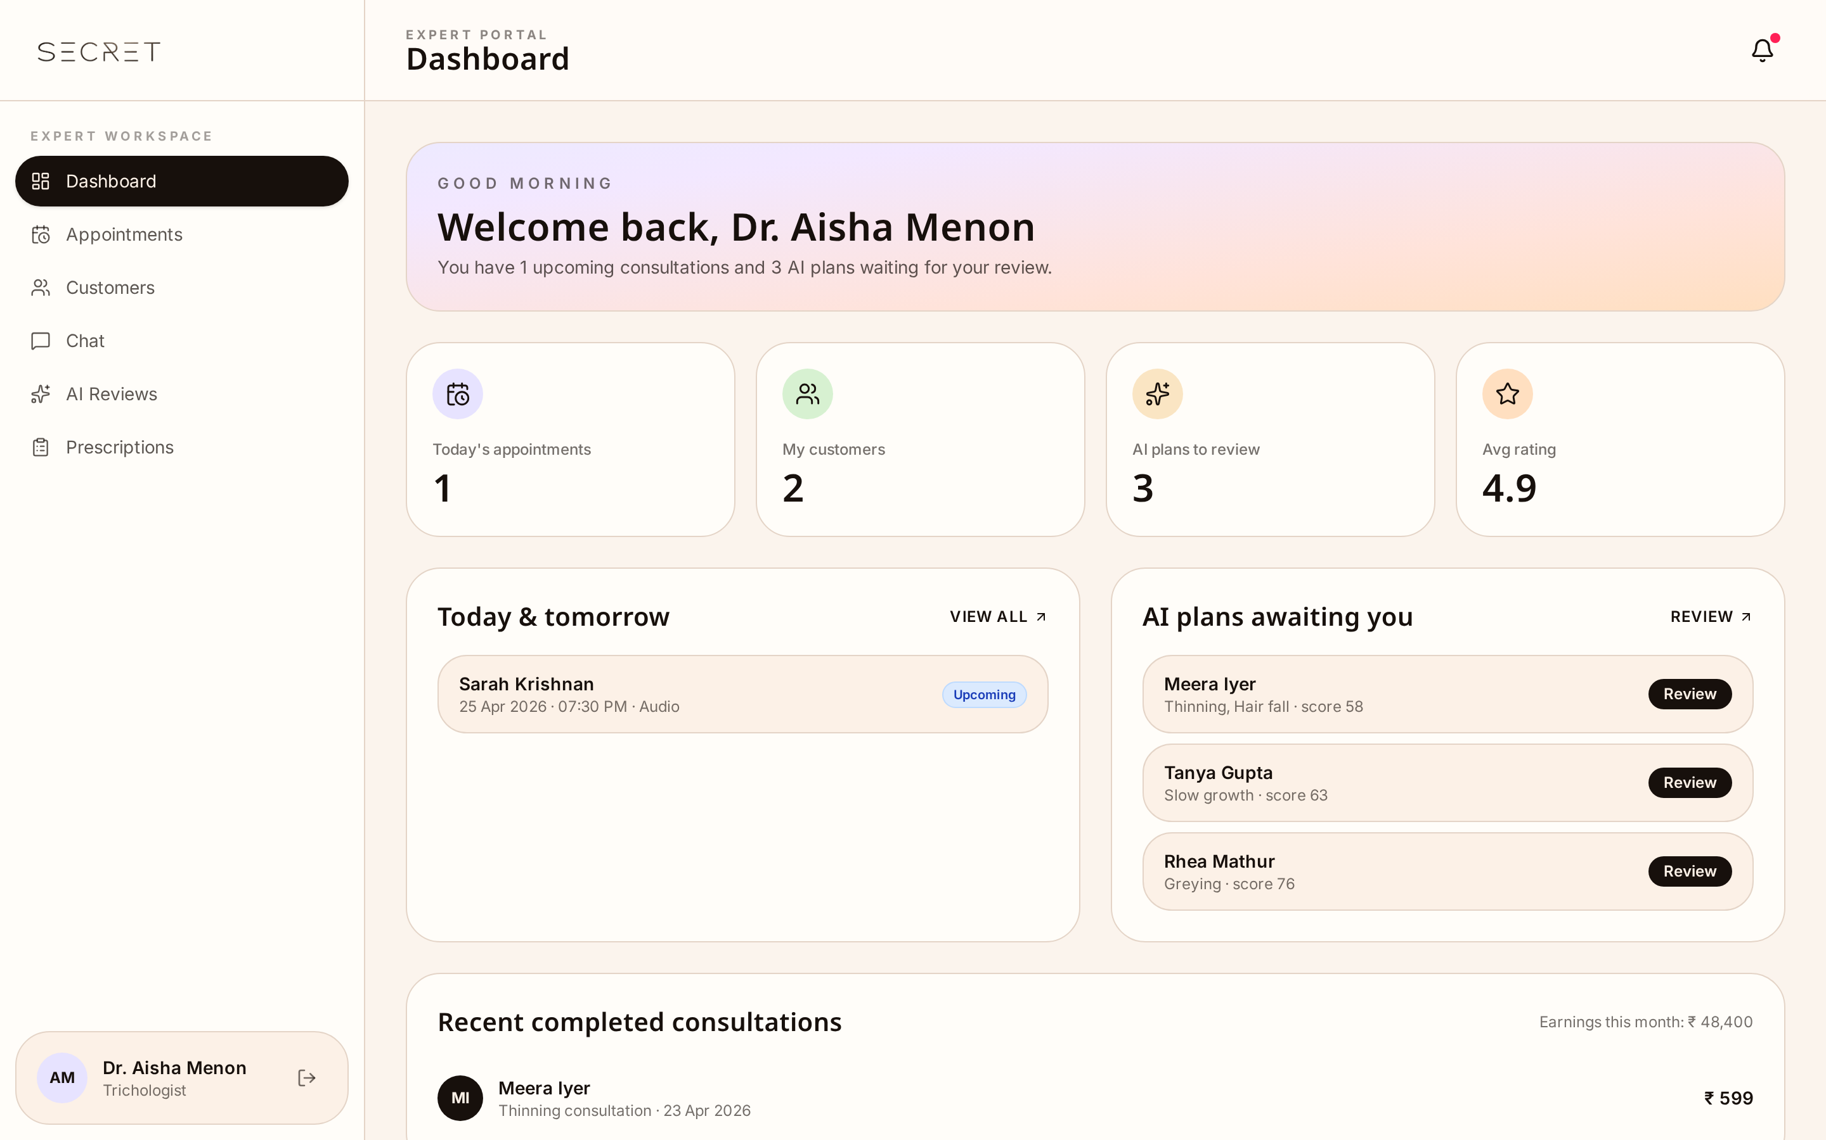
Fig. 21. Expert Dashboard — Client view with consistency alerts.
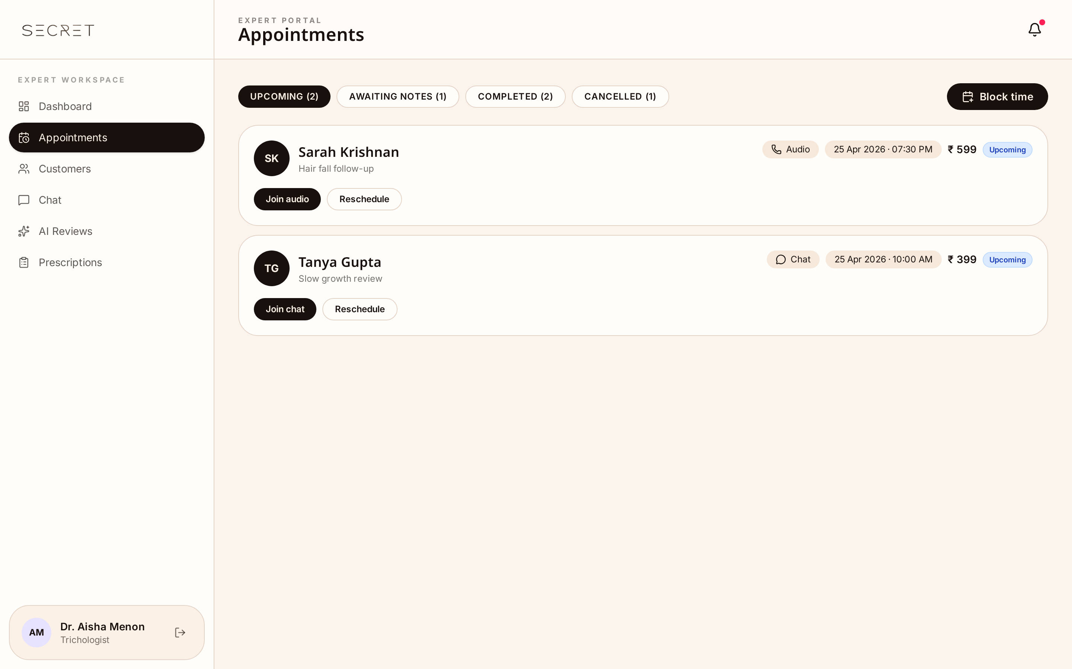
Fig. 22. Appointments — Calendar across video, chat and phone.
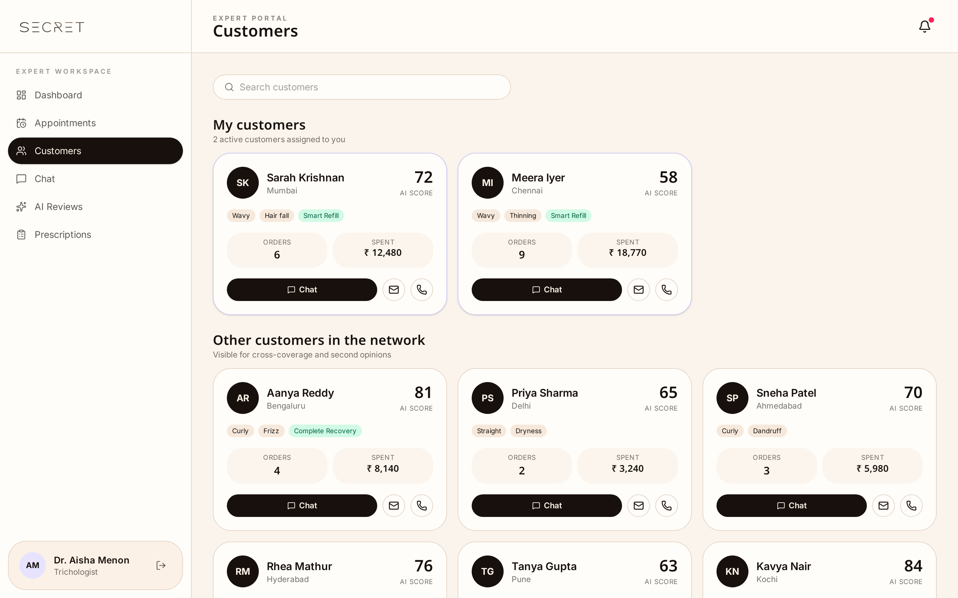
Fig. 23. Client Portfolio — Hair IDs, quiz results, chemical history.
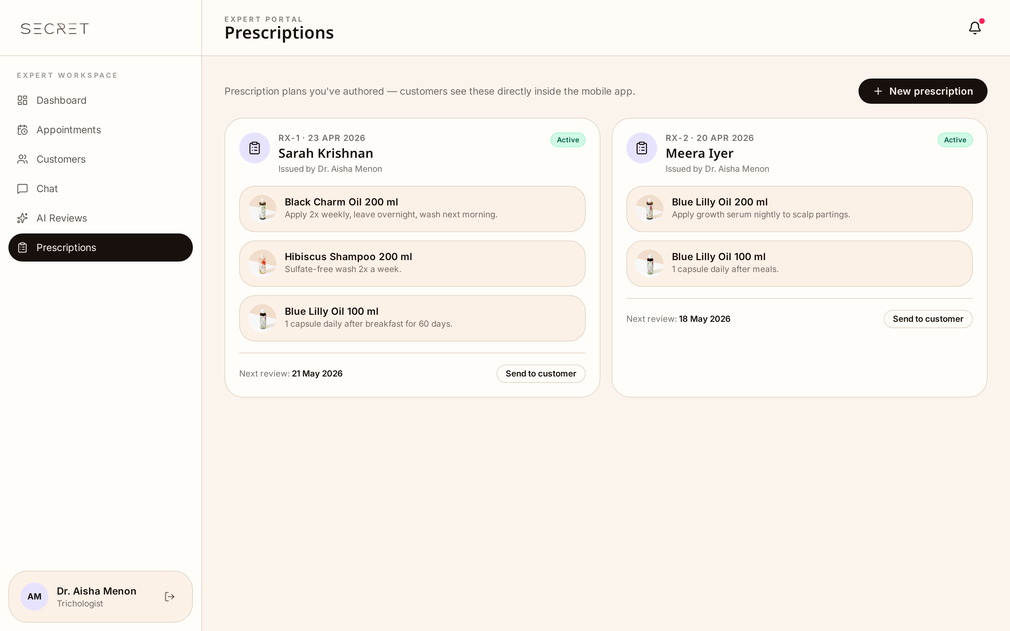
Fig. 24. Prescriptions / Routine — Routine Editor and consultation notes.
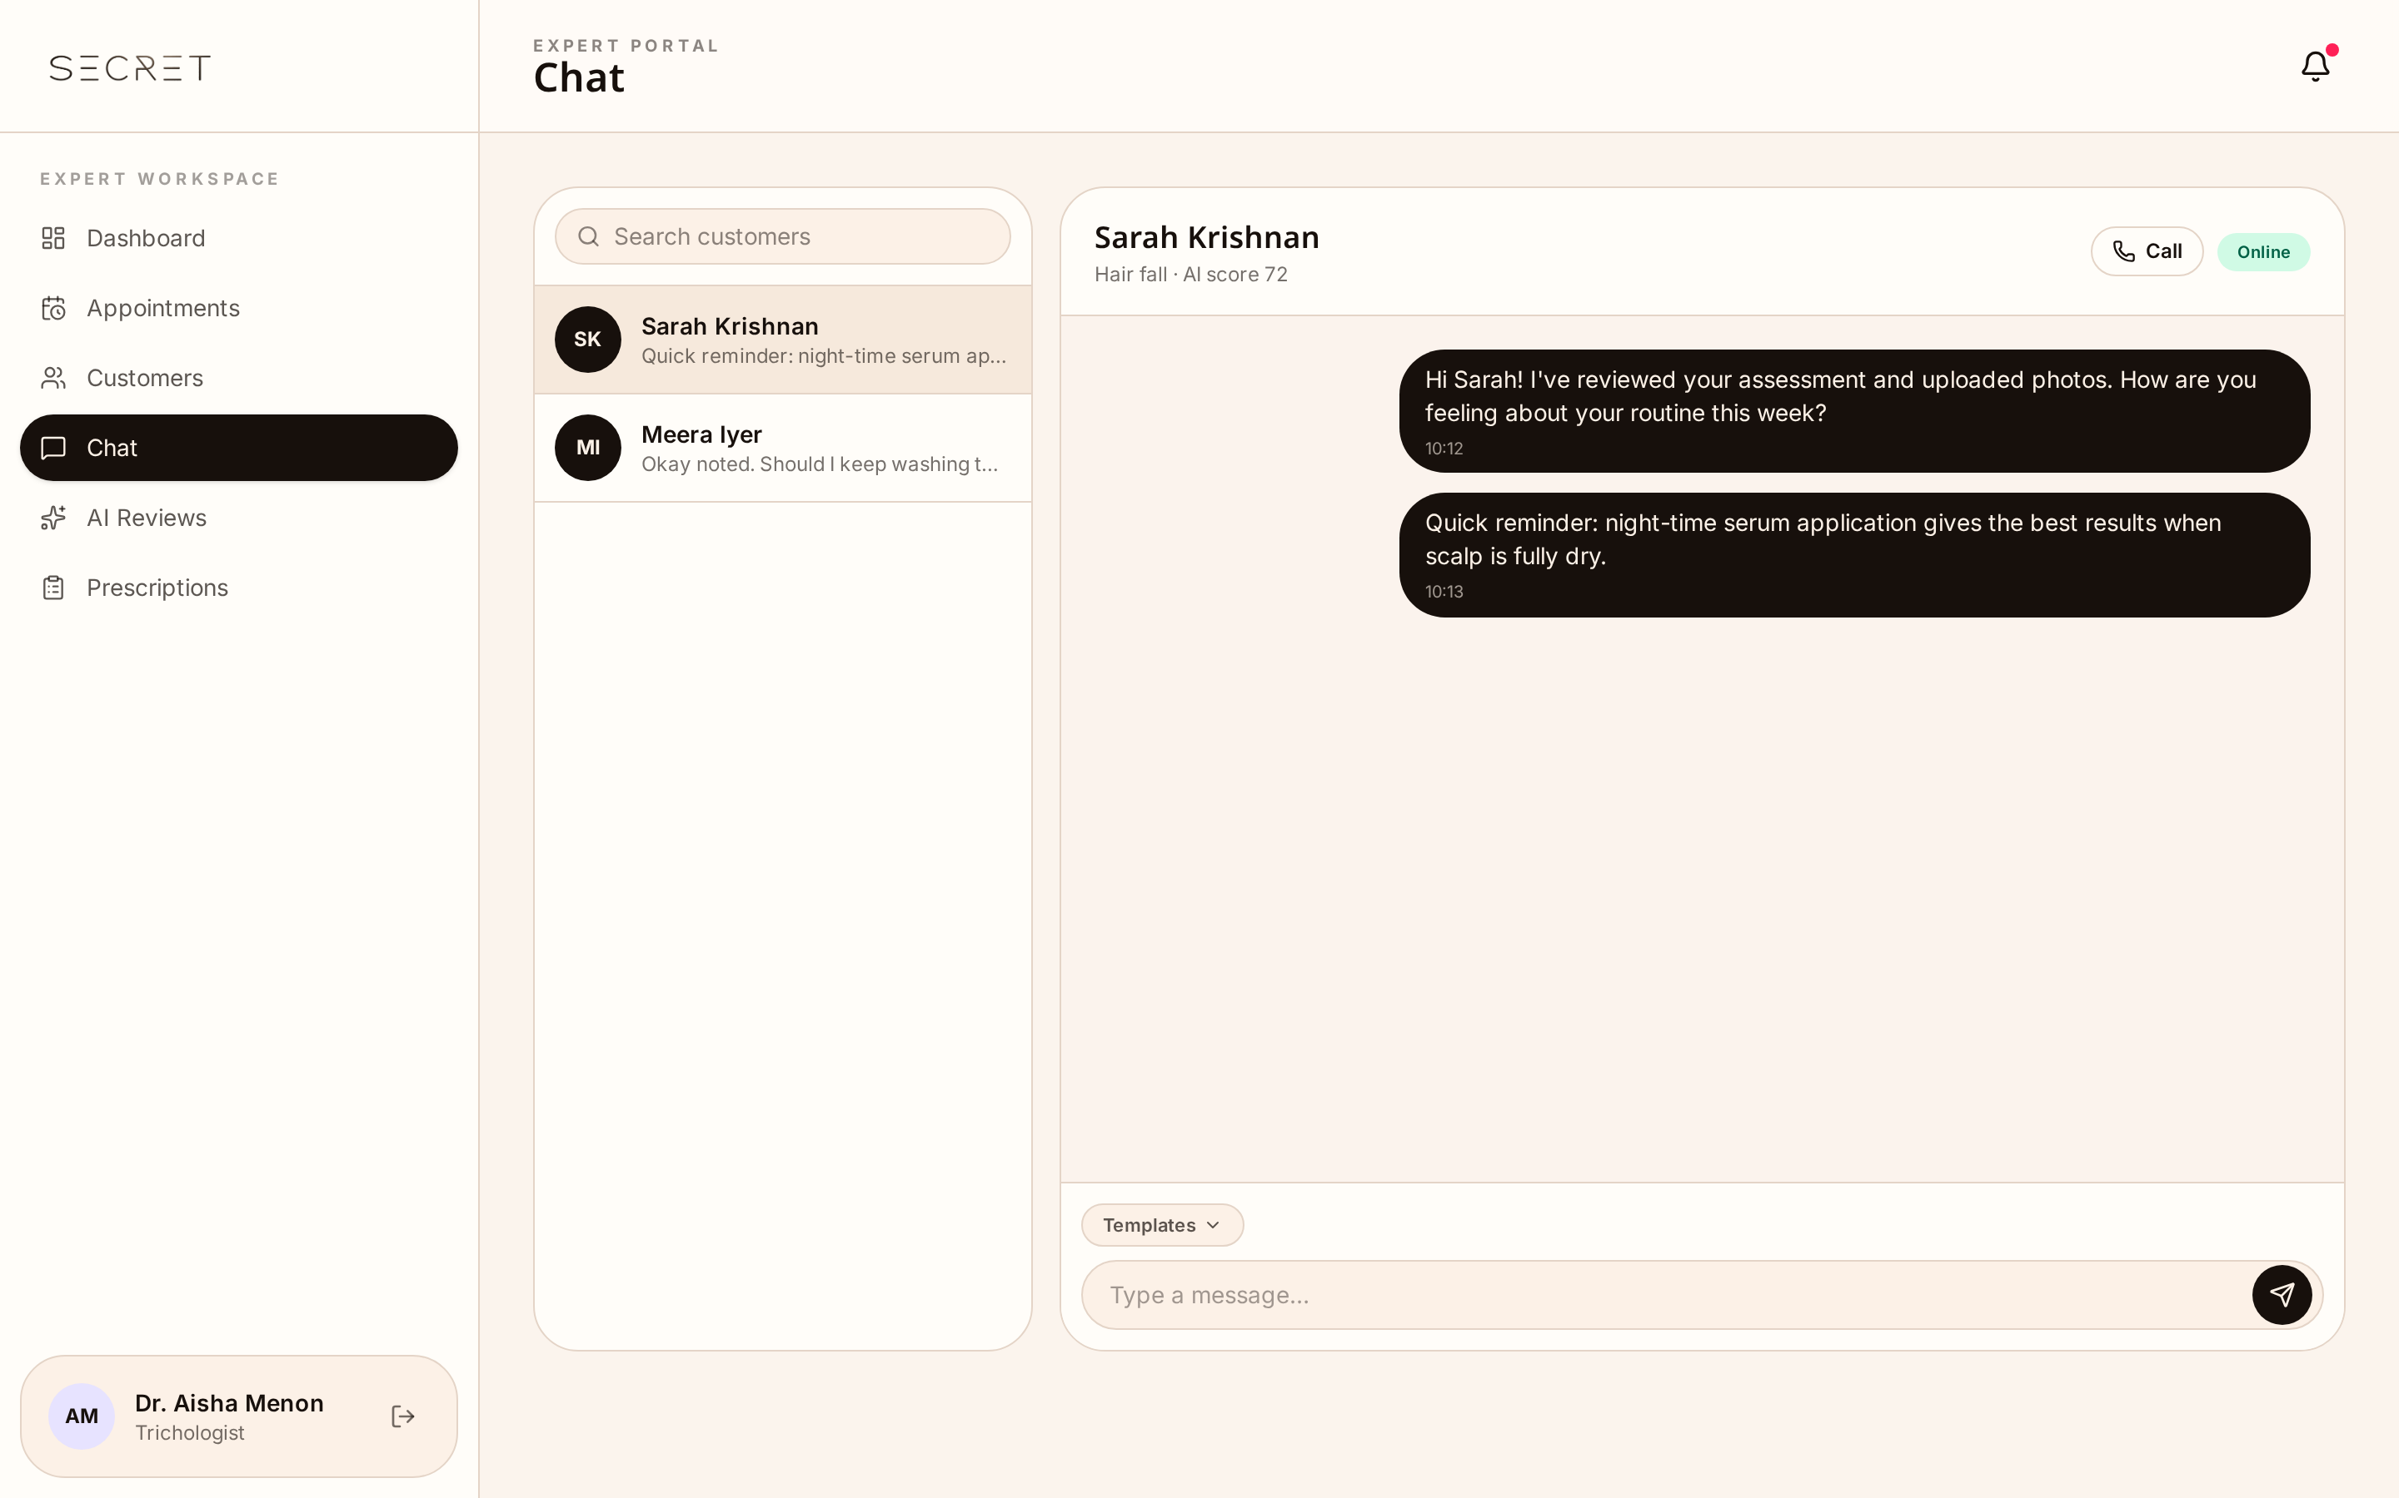
Fig. 25. Client Chat — Secure 1:1 messaging.
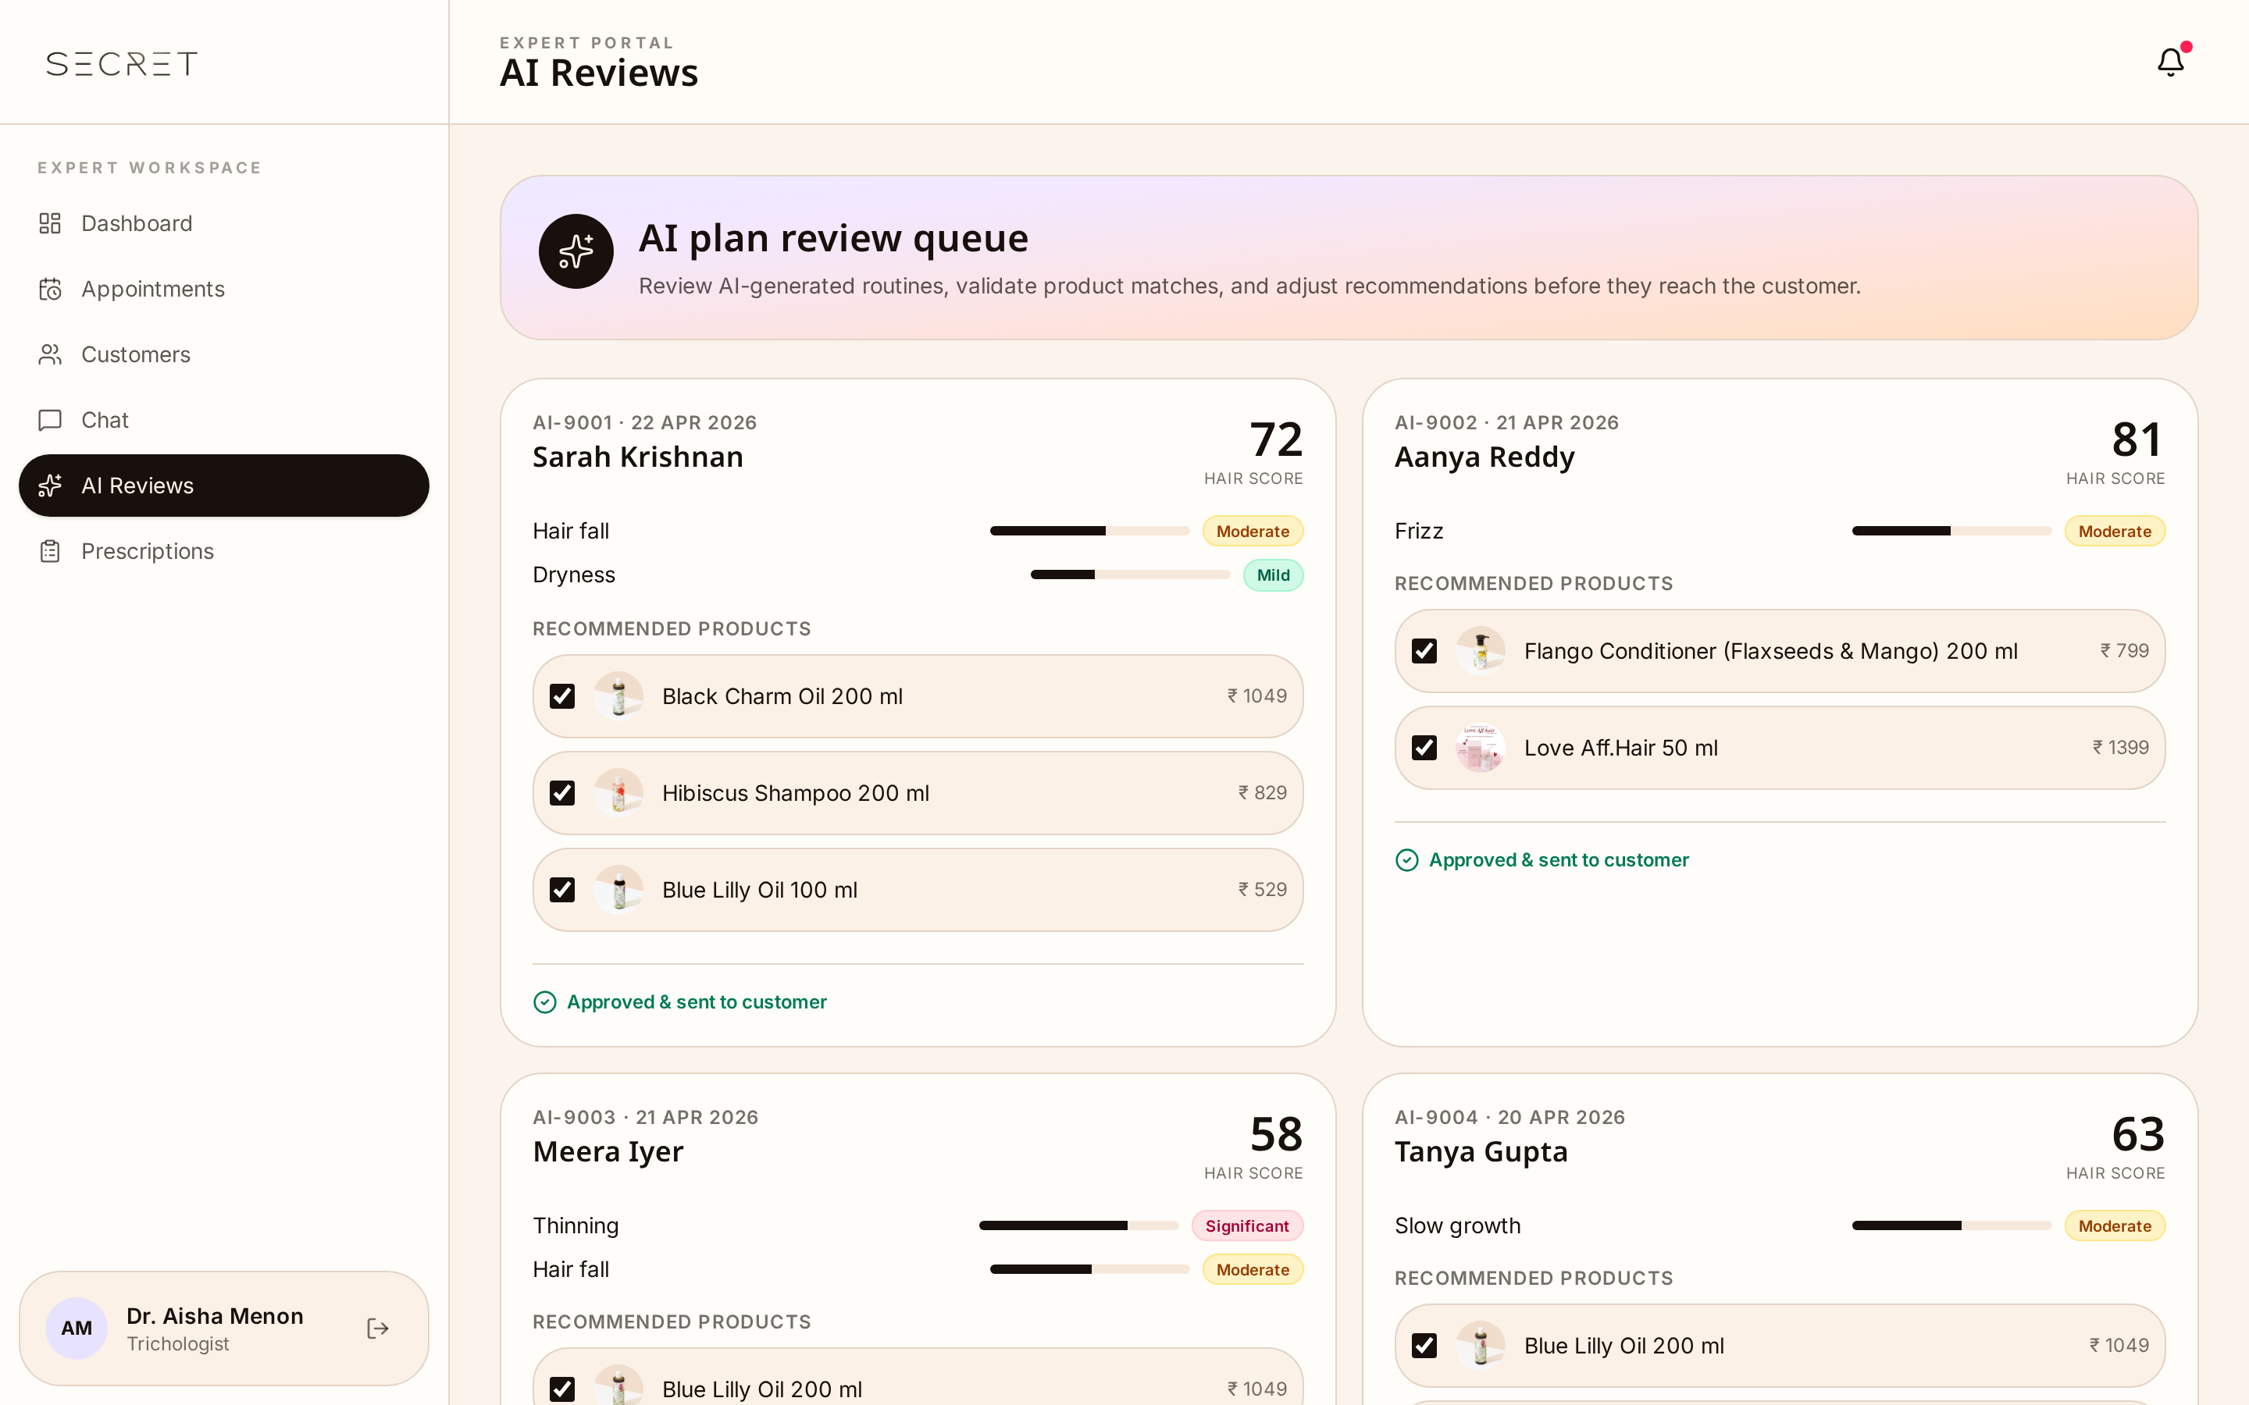
Fig. 26. AI Review — Inspect and override AI routines.

6.4 Admin Panel
The command center for platform owners to manage users, content and the business.
- Control Tower (Dashboard) — platform KPIs including DAU, retention, popular products, subscriptions and revenue.
- Orders & Shipments — single source of truth for orders, refunds, carrier tracking, ETAs and exceptions.
- Product Database (CMS) — add and tag products with ingredients so they surface correctly in the Matchmaker.
- Customers, Experts & Consultations — onboard and vet experts, assign clients, manage tickets and view all bookings.
- Subscriptions — recurring revenue cohort with active plans, churn, MRR and renewal pipeline.
- Content & Journal CMS — author and schedule blog posts, banners and announcements.
- AI Recommendations — tune the matchmaker / routine builder rules without engineering involvement.
- Settings & Roles — brand settings, payment gateways, shipping zones and team role management.
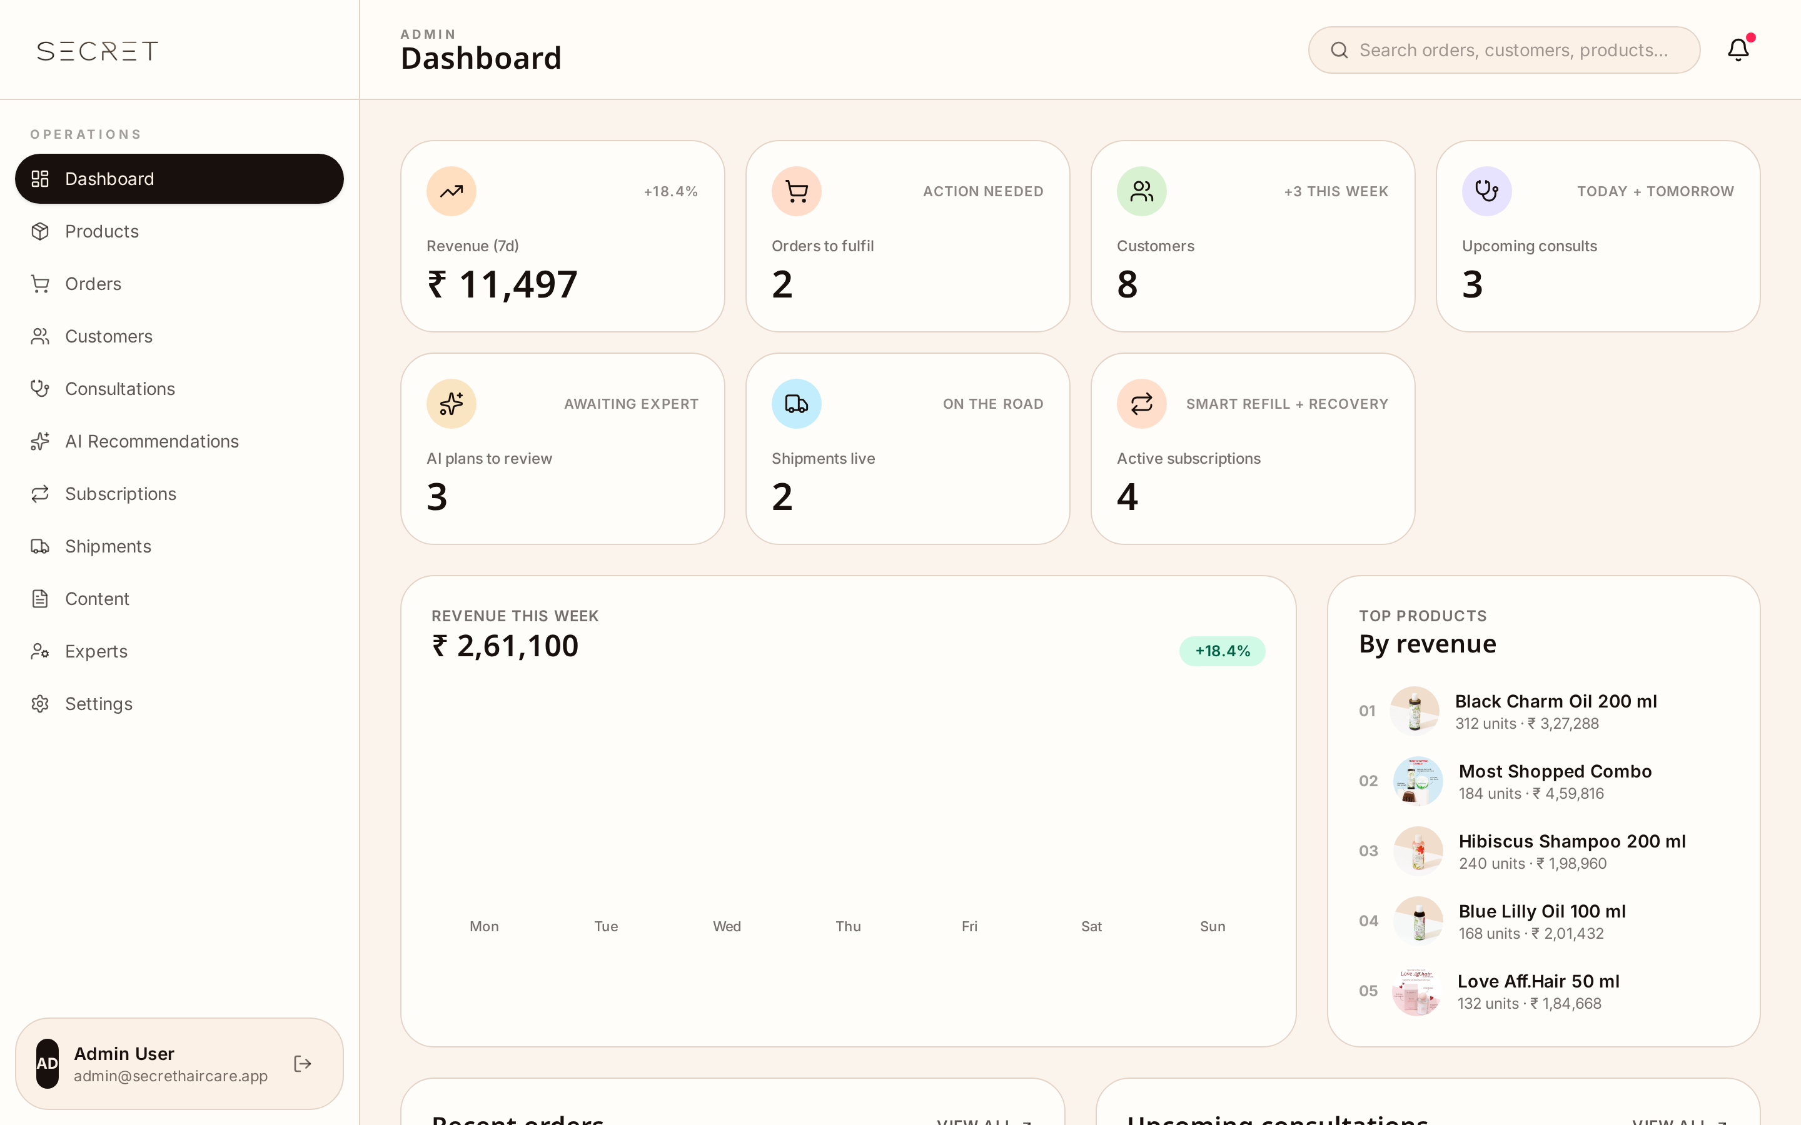
Fig. 27. Control Tower — Platform KPIs and revenue.
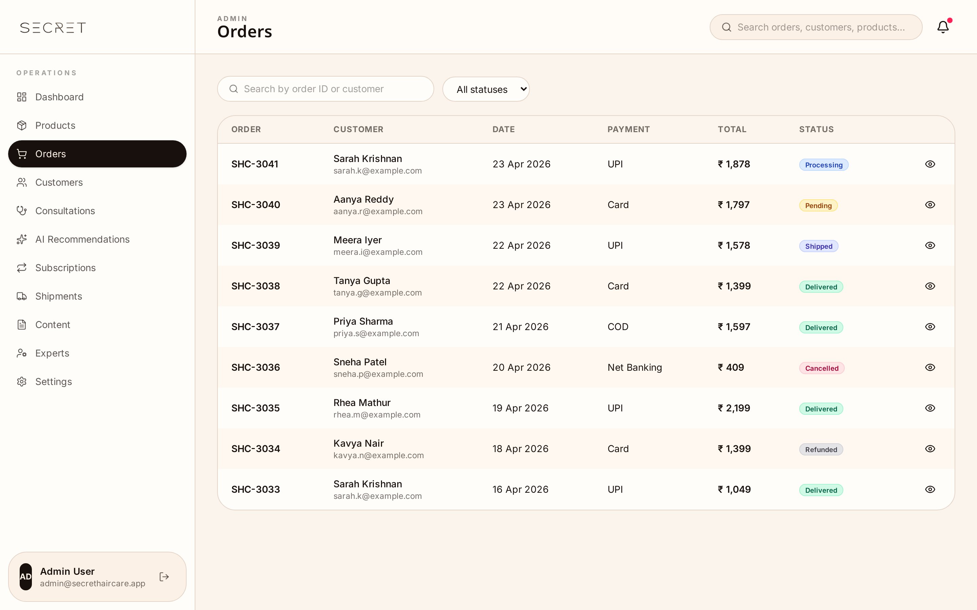
Fig. 28. Orders — Status timelines, refunds, bulk fulfillment.
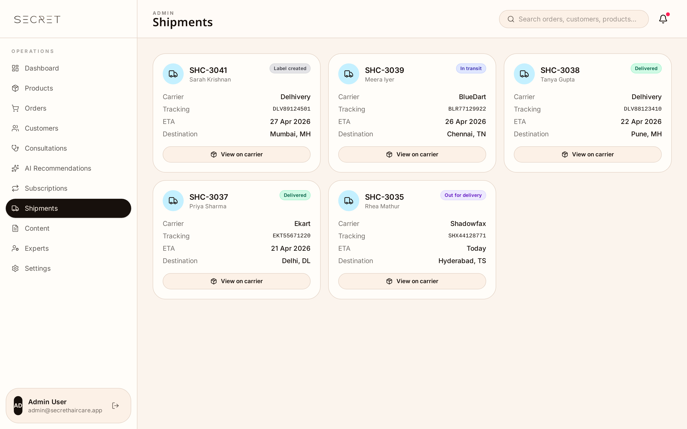
Fig. 29. Shipments — Carrier tracking, ETAs and exceptions.
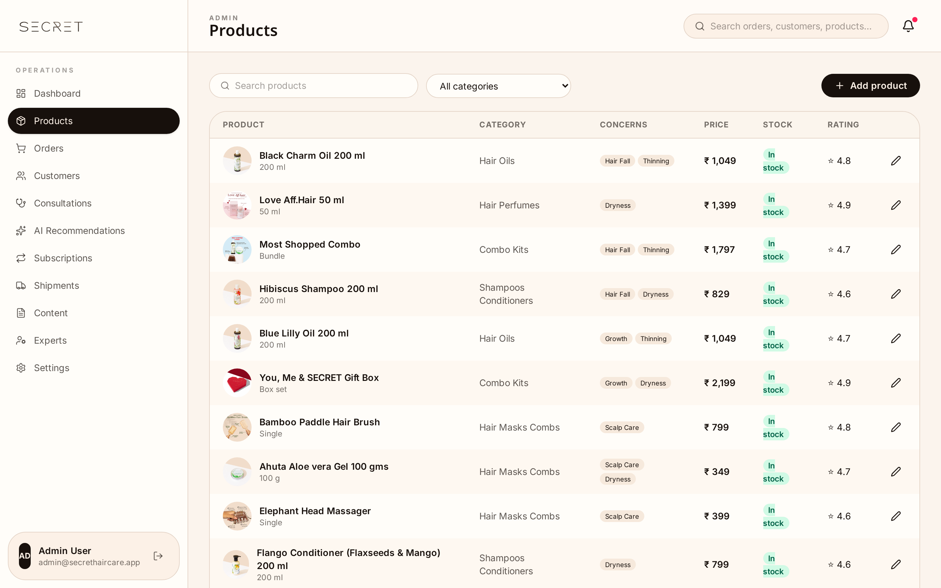
Fig. 30. Product Database (CMS) — Ingredient tagging feeds the Matchmaker.
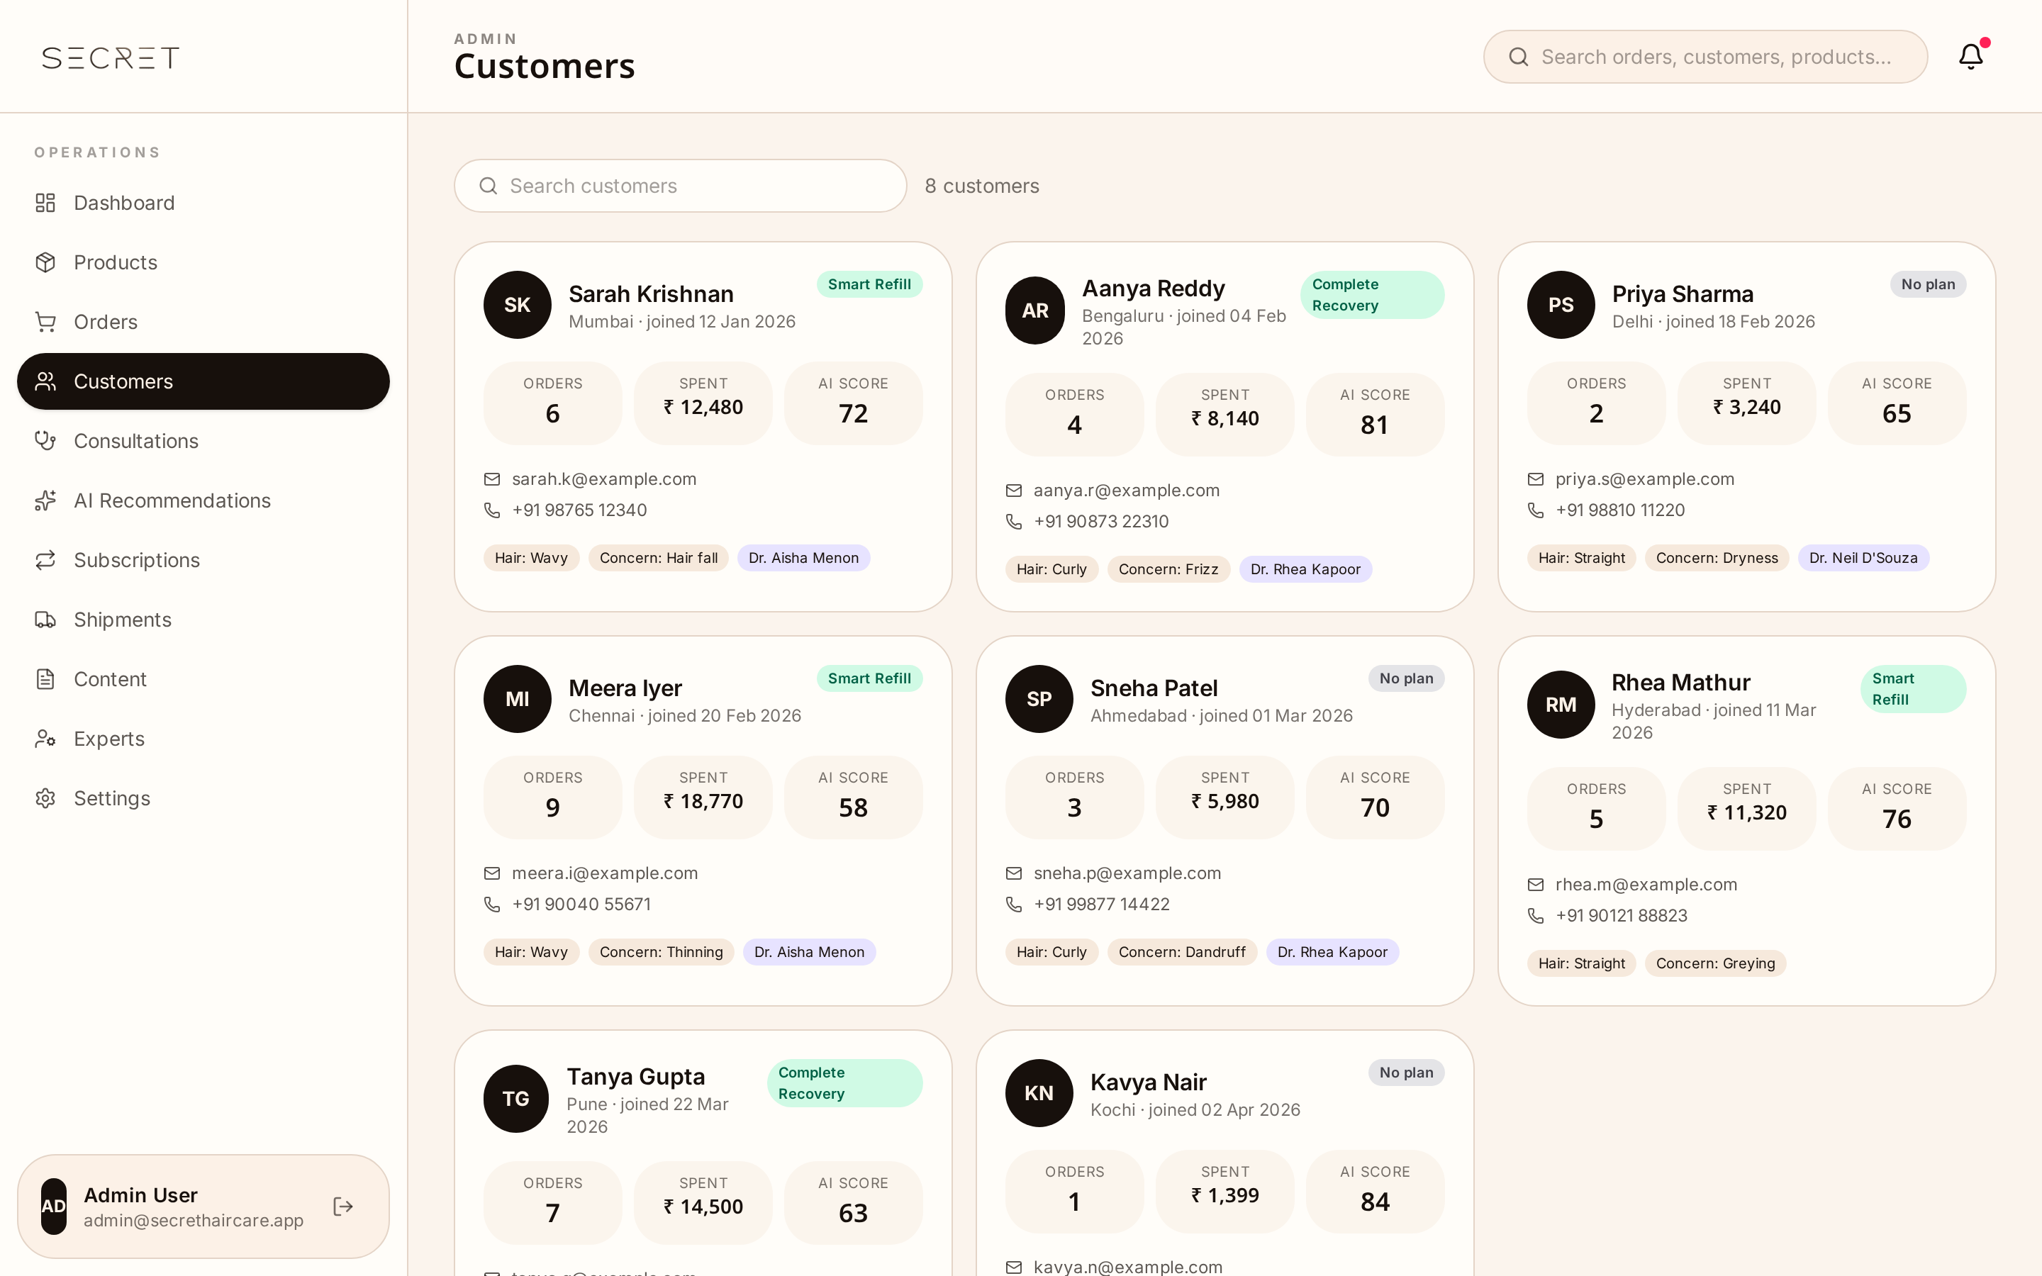
Fig. 31. Customers — Hair IDs, lifetime value, support history.
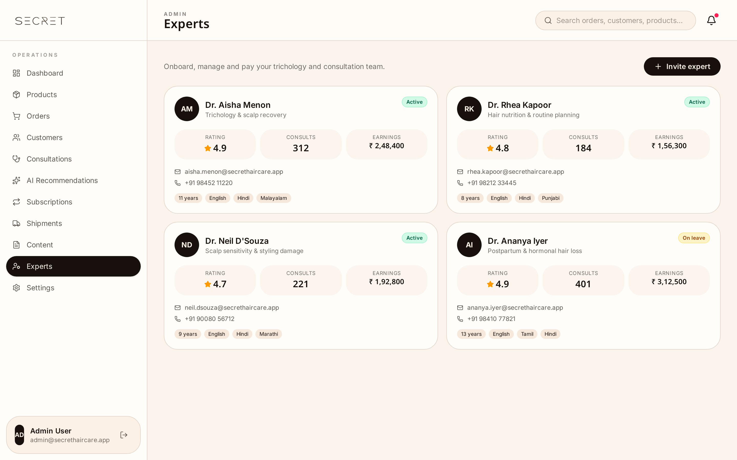
Fig. 32. Experts Management — Onboard, vet and monitor experts.
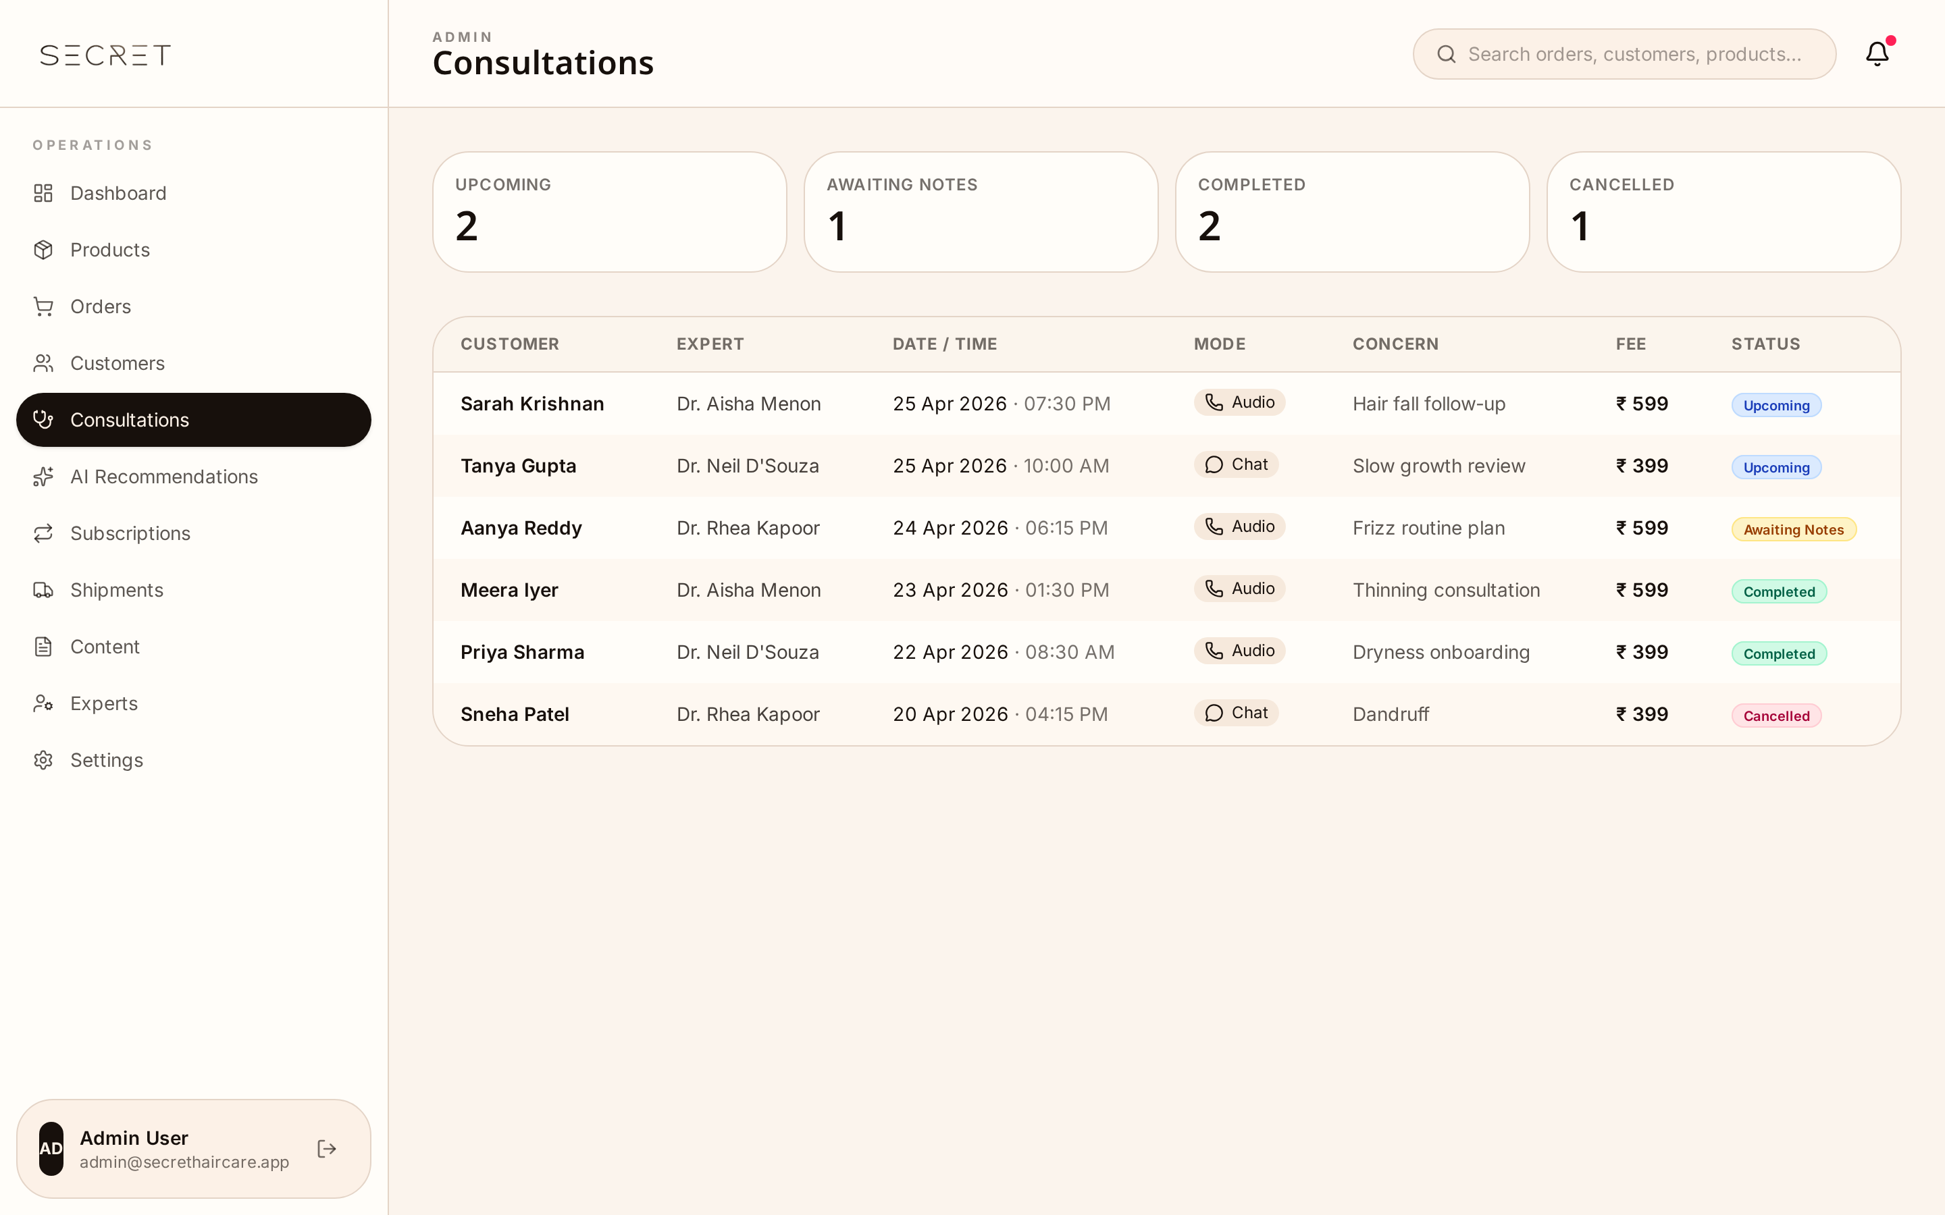
Fig. 33. Consultations — Bookings across all modes.
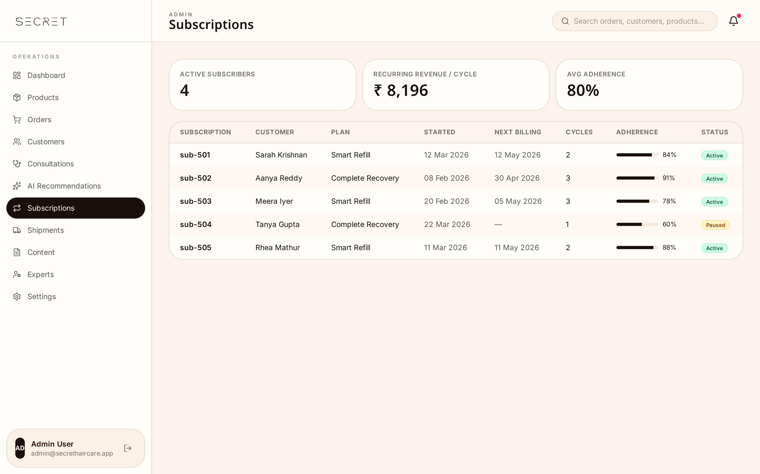
Fig. 34. Subscriptions — Active plans, churn, MRR and renewals.
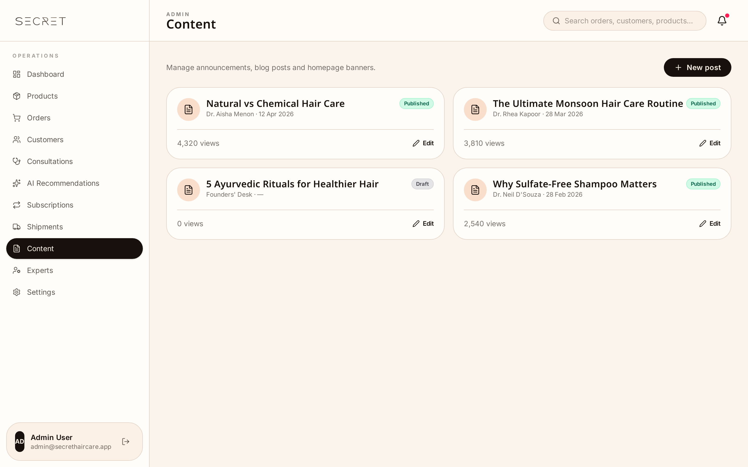
Fig. 35. Content & Journal CMS — Blog, banners, announcements.
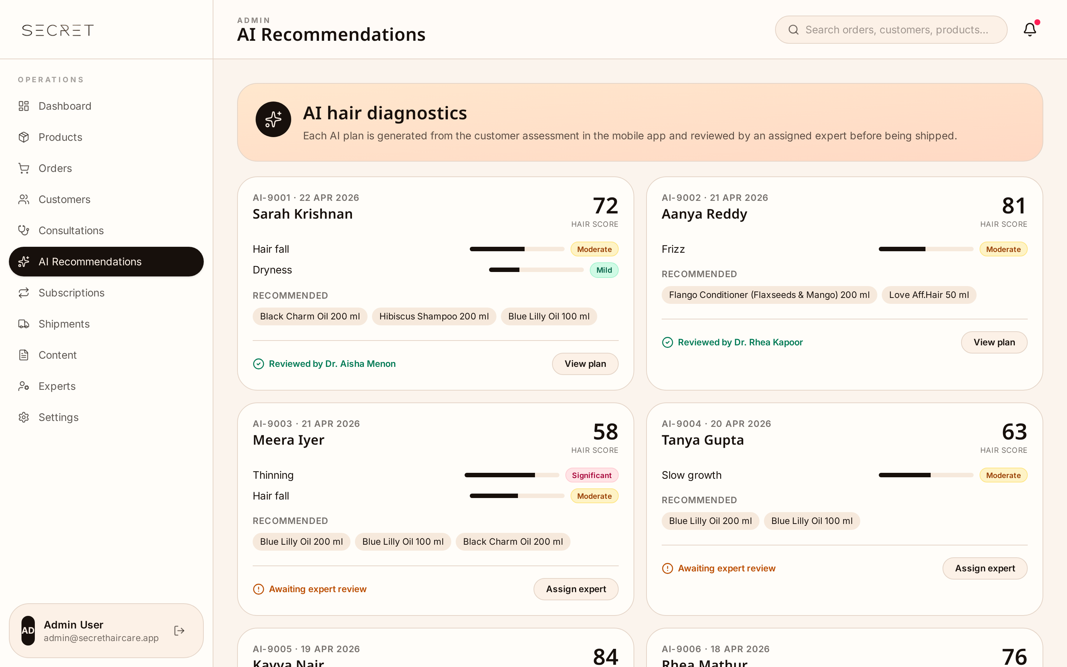
Fig. 36. AI Recommendations — Tune the matchmaker rules.
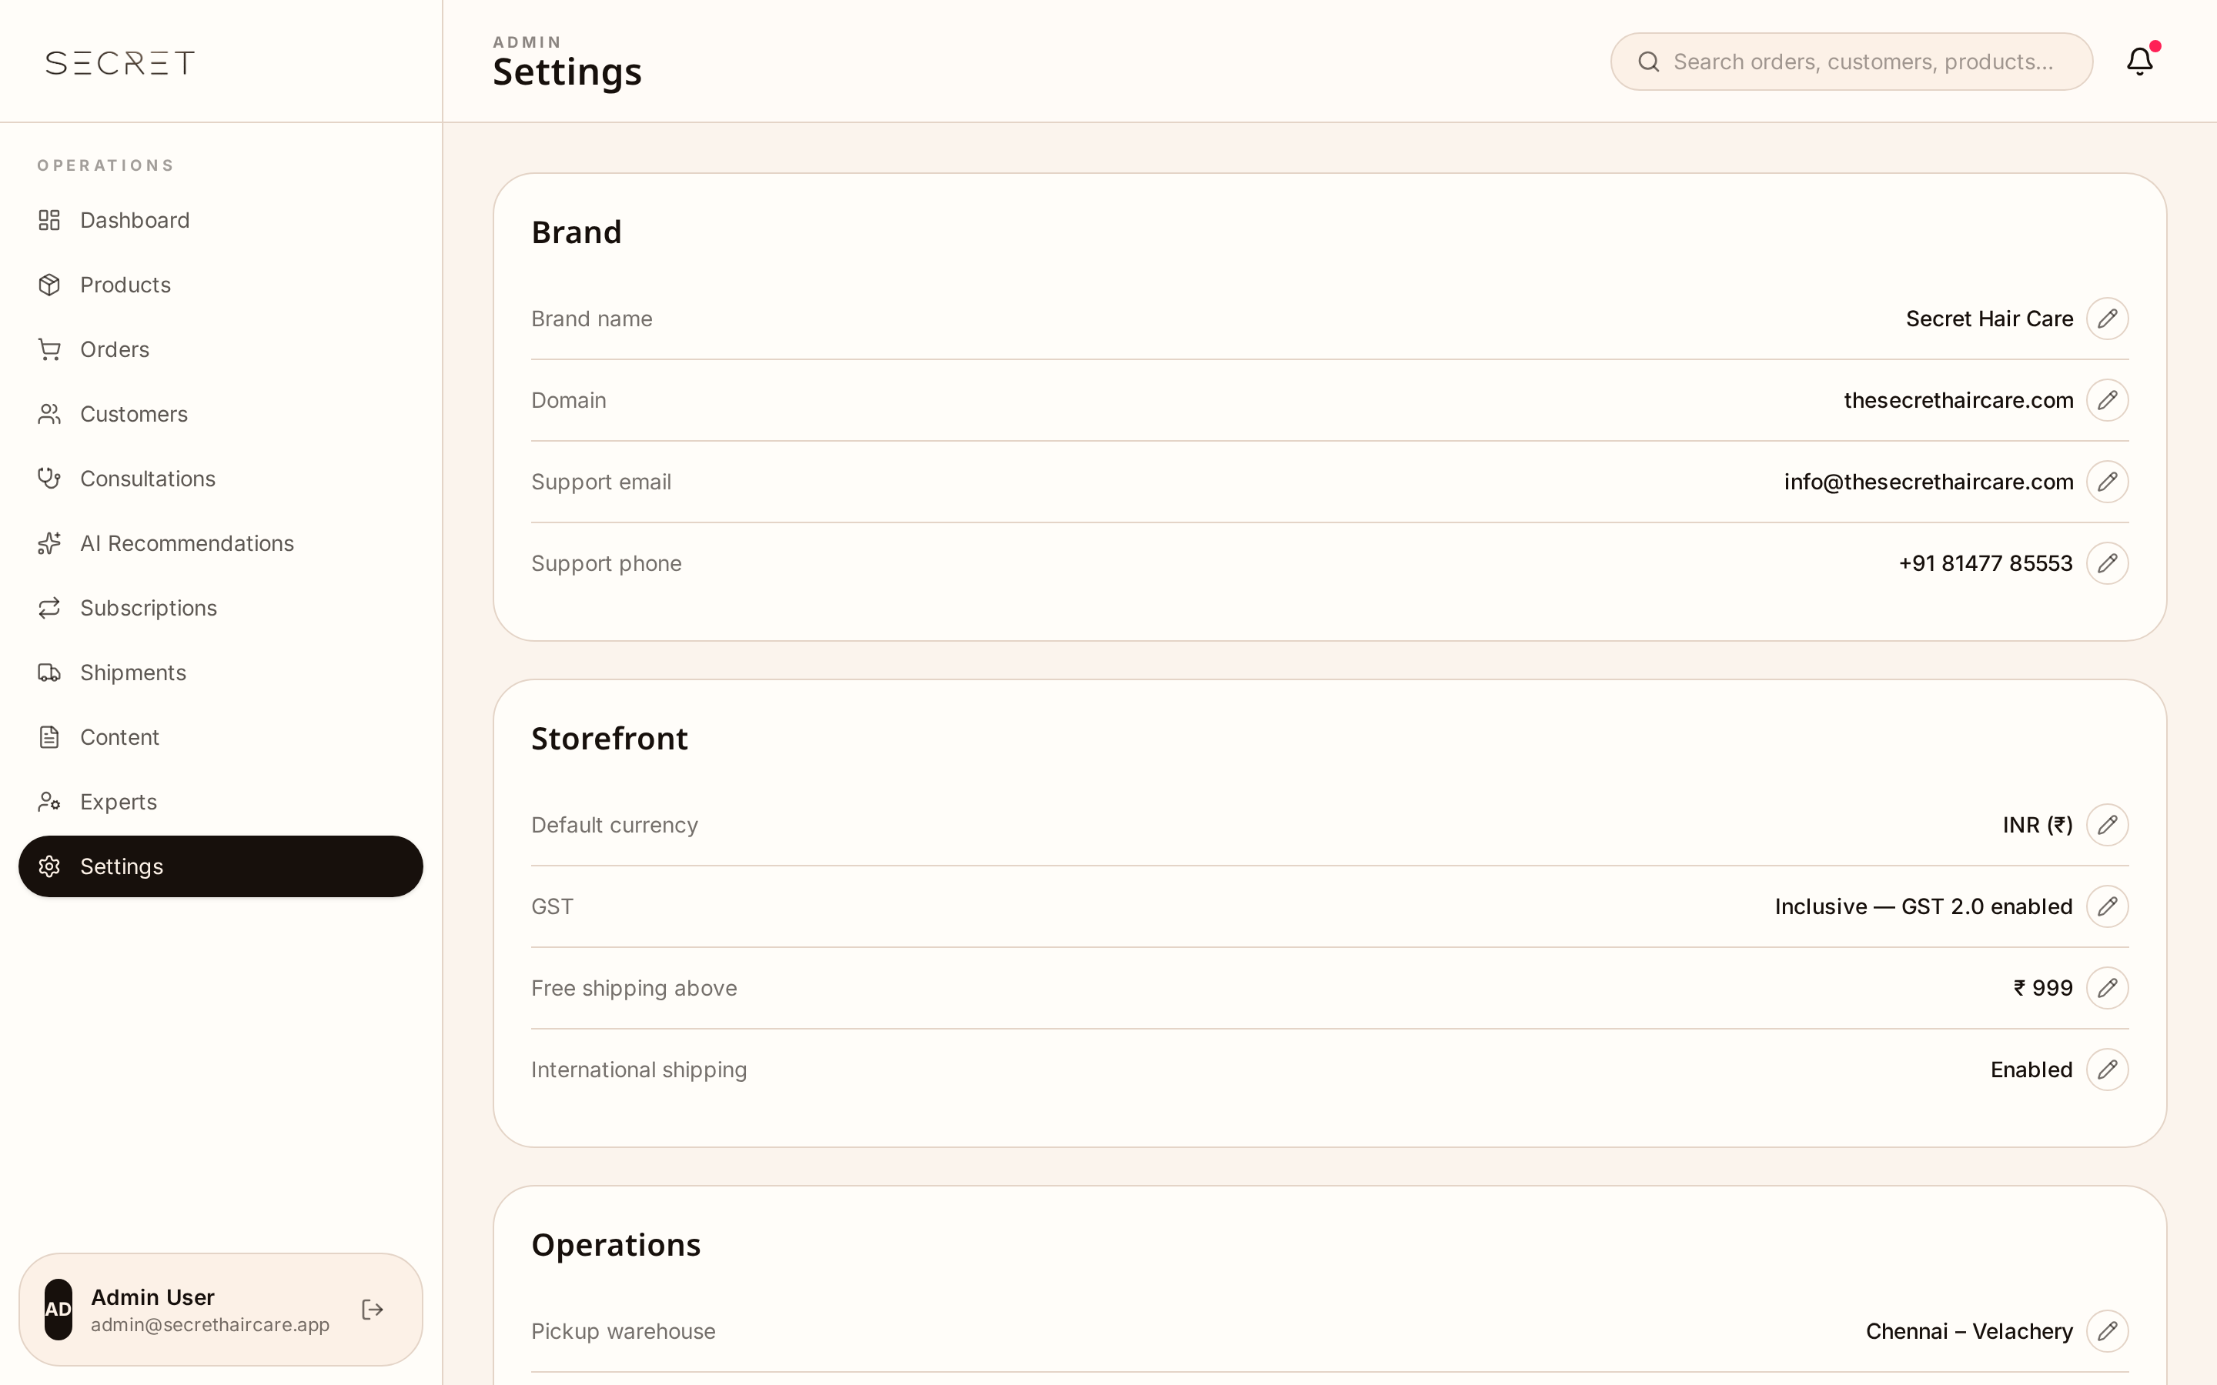
Fig. 37. Settings & Roles — Brand, payments, shipping, team.

7. Implementation Roadmap (4 Phases)
The project will be delivered over an accelerated 12-week timeline, mapped to a total project cost of ₹9.30 Lakhs + 18% GST, divided into four distinct, value-driven phases that deliver all four interfaces.
Phase | Timeline | Scope of Work | Cost (INR)
Phase 1 — Foundation & Consumer Core | Weeks 1 – 3 | UI/UX design system, cloud infrastructure, unified database, secure role-based authentication, Hair Assessment Quiz, Consumer Mobile App (PWA) core — Today's Dashboard and Routine Calendar. | ₹2,32,500
Phase 2 — The Journey & Product Matchmaker | Weeks 4 – 6 | Intelligent matching algorithm, secure photo upload, Compare slider, Consumer Web App — Analytics dashboard and Product Cabinet/Matchmaker, push notification & email reminders. | ₹2,32,500
Phase 3 — Expert & Admin Portals | Weeks 7 – 9 | Expert's Panel — Client Portfolio, Journey Reviewer, Routine Editor. Admin Panel — Control Tower, User Management, Product Database CMS. | ₹2,79,000
Phase 4 — Optimization, QA & Go-Live | Weeks 10 – 12 | End-to-end QA across all 4 platforms, performance optimization, User Acceptance Testing, final production deployment and codebase handover. | ₹1,86,000

8. Team Structure
Role | Key Responsibilities
Project Manager | Primary point of contact; ensures every milestone is hit on time and within budget.
UI/UX Designer | Crafts the intuitive interface ensuring the apps look premium, clean and engaging across all personas.
Full-Stack Developer | Writes the core logic, builds the four interfaces and connects the frontend to backend databases.
QA Engineer | Conducts rigorous automated and manual testing to keep the platform bug-free and data secure across all portals.

9. Commercials

Option 1
Total Project Cost: ₹9,30,000 + 18% GST
The structure is divided into milestone-based payments aligned with the four delivery phases to ensure continuous value delivery.
Note: This proposal covers custom software design, development and deployment services. It does not include third-party hosting costs (e.g. AWS / Vercel) or domain registrations.
Phase | Milestone | % Allocation | Amount (INR)
Phase 1 | Foundation & Consumer Core | 25% | ₹2,32,500
Phase 2 | The Journey & Product Matchmaker | 25% | ₹2,32,500
Phase 3 | Expert & Admin Portals | 30% | ₹2,79,000
Phase 4 | Optimization, QA & Go-Live | 20% | ₹1,86,000
Total | Full End-to-End Delivery | 100% | ₹9,30,000
All amounts above are exclusive of taxes. 18% GST will be applicable on each milestone invoice.

Option 2
Total Project Cost: ₹6,30,000 + 18% GST
Robust, scalable and modern ecommerce website and mobile app without AI recommendation and subscription modules.
Note: As both the e-commerce website and mobile application are designed to operate on a shared backend infrastructure, choosing to proceed with only one of these platforms will result in a cost reduction of ₹84,000, as the common backend development is shared across both solutions.

10. Expected Business Impact
- High Retention — health and habit-tracking apps with visual progress see ~3x higher 90-day retention vs. standard utility apps.
- Monetization Readiness — naturally lends itself to affiliate marketing, brand partnerships, or a premium tier (e.g. 'The Secret Hair Care PRO').
- Community Building — a central hub where users feel understood and guided builds immense brand loyalty.

11. Risks & Mitigation
Risk | Mitigation
User Drop-off | Gamification (streaks, achievement badges) and well-timed, non-intrusive push notifications keep users engaged.
Data Privacy | Hair and face photos are highly personal — enterprise-grade encryption and strict privacy policies ensure user data is never compromised.
Scope Creep | With four portals, scope is tightly managed via strict agile delivery, MVP boundaries in Phase 1, and change-request protocols.

12. Future Roadmap (Post-Launch)
While the initial four phases cover the complete core ecosystem, the architecture is built to support future scaling:
- Native App Stores — wrap the PWA into React Native for official deployment on the App Store and Google Play.
- AI Computer Vision — machine-learning models to automatically analyze uploaded photos for split ends, frizz or thinning.

Accepted by Client | For The Development Team
Name, Designation & Date | Authorised Signatory & Date
Prepared by Kods — for The Secret Hair Care.
Document classification: Confidential.
—— END OF DOCUMENT ——

